

Introduction

##### CHAPTER 1:INTRODUCTION

* 1. Company Profile
  2. Project Introduction
  3. Existing System and Need for System
  4. Scope of Work
  5. Operating Environment - Hardware and Software
  6. Detail Description of Technology Used

##### Company Profile

Name Of Company : **TROGA Infotech**

Company Address : **Loni Babhaleshwar Road , Loni**

Branch Office : **Near Suvidha Complex**

**Number Of Empolyees :**

Mr. Gaurav Dhumal Mr. Omkar Deshmukh

Mr. Tejas Gopale Mr. Rahul Deokar

Mr. Atharva Aher

**Company CEO :**

**List Of Platform :**

1. JAVA
2. BootStrap
3. MySql
4. Javascript

##### Project Introduction

Online hospital management system: A unique cloud based hospital management system for both patients and hospital stuffs (Doctors, Management). The primary target of this design is to make hospital experience better than we currently have. Hospital is a place where no one willingly wants to visit but there are times when we need to. The old system of hospitals are not very user friendly. The first big stem is waiting in the queue for long hours. There are lots of other problems that makes your hospital experience bad. Our main focus is to make peoples life easier in the hour of need. We are working to design such a system that will reduce a lot of paperwork and save peoples time.

Online Hospital Management System is powerful, flexible, and easy to use and is designed and developed to deliver real conceivable benefits to hospitals.

Hospital Management System is designed for multispeciality hospitals, to cover a wide range of hospital administration and management processes. It is an integrated end-to-end Hospital Management System that provides relevant information across the hospital to support effective decision making for patient care, hospital administration and critical financial accounting, in a seamless flow. Hospital Management System is a software product suite designed to improve the quality and management of hospital management in the areas of clinical process analysis and activity- based costing. Hospital Management System enables you to develop your organization and improve its effectiveness and quality of work. Managing the key processes efficiently is critical to the success of the hospital helps you manage your processes.

##### EXISTING SYSTEM AND NEED FOR SYSTEM

Existing System

Existing system is patient do not take the appointments of particular doctor. Facilities in the hospital are not known to the users. Existing provide information about hospital are only available within the hospital. Not solved any problems.

Need of System:

This System can be used by simple users who are take online appointments of particular doctor..Scope of project is that it gives only some specified information about hospital. This website can be installed on windows xp 8,10 based operating system .

The proposed system is having following objectives.

* + - User friendliness is provided in the application with various controls.
    - The system makes the overall project management much easier and flexible.
    - It can be accessed over the internet.
    - Vast amount of data can be stored.
    - There is no risk of data mismanagement at any level while the project development is under process.
    - Relationship between the administrator, owner/developer and subcontractor can be maintained very easily.
    - It provides high level of security using different protocols like https etc.
    - The Online Hospital Management System consists of 3 users or modules, they are:
    - Administrator
    - Doctor
    - User or Patient

##### SCOPE Of WORK

1. Information about Patients is done by just writing the Patients name, age and gender. Whenever the Patient comes up his information is stored freshly.
2. Bills are generated by recording price for each facility provided to Patient on a separate sheet and at last they all are summed up.
3. Diagnosis information to patients is generally recorded on the document, which contains Patient information. It is destroyed after some time period to decrease the paper load in the office.
4. Immunization records of children are maintained in pre-formatted sheets, which are kept in a file.
5. Information about various diseases is not kept as any document. Doctors themselves do this job by remembering various medicines. All this work is done

manually by the receptionist and other operational staff and lot of papers are needed to be handled and taken care of. Doctors have to remember various

medicines available for diagnosis and sometimes miss better alternatives as they can’t remember them at that time

##### Operating Environment - Hardware and Software Software Requirements:

a.User Interface : HTML,CSS

b.Clien Side Scripting : JavaScript c.. programming Languages : java

1. IDE : Eclipse
2. Database : MYSQL 5.1

f.Server : Apache Tomcat 9.0.

##### Hardware Requirements:

a.Processor : AMD A6

b. HDD : Minimum 20 GB

c.. RAM : 2 GB

##### Detail Description of Technology Used:

Why Java?

Java is a widely used programming language expressly designed for use in the [distributed](https://whatis.techtarget.com/definition/distributed) environment of the internet. It is the most popular programming language for Android [smartphone](https://searchmobilecomputing.techtarget.com/definition/smartphone) applications and is also among the most favored for the development of [edge devices](https://searchnetworking.techtarget.com/definition/edge-device) and the [internet of things](https://internetofthingsagenda.techtarget.com/definition/Internet-of-Things-IoT).

**USES OF JAVA**

It is easy for developers to write programs which employ popular software design patterns and best practices using the various components found in Java EE. For example, frameworks such as Struts and JavaServer Faces all use a Java [servlet](https://searchmicroservices.techtarget.com/definition/servlet) to implement the front controller design pattern for centralizing requests.

##### History of Java

The internet and th[e World Wide Web](https://whatis.techtarget.com/definition/World-Wide-Web) were starting to emerge in 1996 and Java was not originally designed with the internet in mind. Instead, [Sun](https://www.theserverside.com/definition/Sun-Microsystems) [Microsystems](https://www.theserverside.com/definition/Sun-Microsystems) engineers envisioned small, appliance-sized, interconnected devices that could communicate with each other.

As a result, the Java programming language paid more attention to the task of network programming than other competing languages. Through the java.net APIs, the Java programming language took large strides in simplifying the traditionally difficult task of programming across a network.

J2EE

Java 2 Enterprise Edition is a programming platform part of the Java Platform for developing and running multitier architecture Java applications, based largely on modular software components running on an application server.

TOMCAT-

It’s an application server which is mostly used in the web-applications. It implements the Servlet 2.5 &JSP 2.1 specifications. It’s a cross-platform application Server.

JSP

Java Server Pages(JSP) is a server side Java technology that allows software developers to create dynamically generated web pages, with HTML, XML or other document types. JSPs are compiled into Servlets by a JSP compiler

SERVLET

Servlets are Java programming language objects that dynamically process requests & construct responses. The Servlet APIs are contained in the javax.servlet & javax.servlet.http packages. Servlets can be generated automatically by Java server (JSP Pages) compiler. NetBeans IDE NetBeans is the most comprehensive J2EE IDE() for the open Source netbeans platform.It incorporates most innovative open standard technologies to provide a development environment for J2EE WEB,XML,UML & database & a wide array of application server connectors to streamline development ,deployment, testing , portability.It’s a cross-platform.

##### Introduction to JSP

* + - It stands for Java Server Pages.
    - It is a server side technology.
    - It is used for creating web application.
    - It is used to create dynamic web content.
    - In this JSP tags are used to insert JAVA code into HTML pages.
    - It is an advanced version of Servlet Technology.
    - It is a Web based technology helps us to create dynamic and platform independent web pages.
    - In this, Java code can be inserted in HTML/ XML pages or both.
    - JSP is first converted into servlet by JSP container before processing the client’s request.

##### SP pages are more advantages than Servlet:

* + - They are easy to maintain.
    - No recompilation or redeployment is required.
    - JSP has access to entire API of JAVA .
    - JSP are extended version of Servlet.

##### Features of JSP

* + - **Coding in JSP is easy** :- As it is just adding JAVA code to HTML/XML.
    - **Reduction in the length of Code** :- In JSP we use action tags, custom tags etc.
    - **Connection to Database is easier** :-It is easier to connect website to database and allows to read or write data easily to the database.
    - **Make Interactive websites** :- In this we can create dynamic web pages which helps user to interact in real time environment.
    - **Portable, Powerful, flexible and easy to maintain** :- as these are browser and server independent.
    - **No Redeployment and No Re-Compilation** :- It is dynamic, secure and platform independent so no need to re-compilation.
    - **Extension to Servlet** :- as it has all features of servlets, implicit objects and custom tags

Steps for Execution of JSP are following:-

* + - Create html page from where request will be sent to server eg try.html.
    - To handle to request of user next is to create .jsp file Eg. new.jsp
    - Create project folder structure.
    - Create XML file eg my.xml.
    - Create WAR file.
    - Start Tomcat
    - Run Application

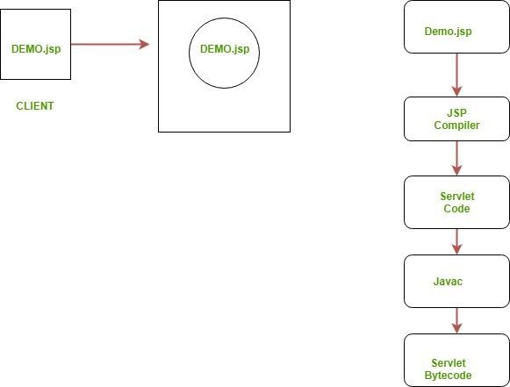



**PROPOSED SYSTEM**

##### CHAPTER 2: PROPOSED SYSTEM

* 1. Proposed System
  2. Objective Of The System
  3. User Requirement

##### Proposed System

Online hospital Management System is a digital application which easily visit online. This website is simple to handle as well as use to noncomputer user also. We can also easily find the required information about Ghati Hospital. We can easily find specialty doctors and take appointment of that doctor.

This software automates and manages the working of hospitals. The database system keeps track of data required for various departments in a hospital. The whole project is divided into following modules:

* + - **Patient Details (IPD/OPD)** :This module keeps record of the indoor patients admitted, new outdoor patients,old outdoor patients revisiting the hospital for check- up, patients discharged, employees working in the hospital, details of the rooms issued to the patients, charges of various rooms, room transfers of the patients within the hospital, receipts for advance and bill payments, etc

**.•Billing** :This module is used for managing the billing of patients including all kinds of charges such as room charges, doctor charges and other miscellaneous charges deducting the net advance paid, if any and discount provided,if any.

* + - **Login** :This module deals with the security matters, user logons and authentications. It is used to create new users, who can login to the software of hospital and change password, if a user finds some security problems. Proper authorization will be done to take care of who is accessing the database – Administrator, CMO, doctor, operator or patient.
* **Reduction of Paper Work**: No need of voluminous files

.•**Speed**: The machine can retrieve and modify data far faster than a human can.

* **Redundancy**: Redundancy of data entry can be eradicated.
* **Cost Saving**: Money spent on papers and files can be saved.
* Easy and Durable Storage
* Ease in the process of handling accounts like bill payments and receipts
* Proper Authorization and Security
* Online Access

##### Objective Of The System

Online Hospital Management System automates and manages the working of hospitals. This is faster and more impressive than the traditional hospital system. The whole project is divided into different modules. The proposed system not only overcomes the loopholes in the existing system but also provides additional features, which will help in better management and also make the work of users easier. The specific objectives of the research are:

* To maintain the record of indoor and outdoor patients

.•To computerize the records of employees working in the hospital, including their financial aspects

.•Automation of billing of patients.

* Management of Hospital Stock Inventory.

The patient record touches, in some way, virtually everyone associated with providing, receiving or reimbursing health care services. This wide range of applications and use has led to efforts to automate the collection, storage and management of the data that constitute these records. But in spite of more than 30 years of exploratory work and millions of dollars in research and implementation of computer systems in health care provider institutions, patient records today are still predominantly paper records. This evident lack of diffusion of information management technologies in the health care sector has limited the tools available for effective decision-making. Given the importance of patient data to the activities of all portions of the health care spectrum,an effort was made to improve patient records, acting in response to expanding demands for information and for increased functional capacity of patient record systems, as well as the considerable recent technological advances that bring the benefits of computer-based patient records within reach.A patient's medical record has always been a dispersed entity. It can be defined as the accumulation of medical information concerning the patient. Ideally, this information is bundled in a single folder with the patient's identification data on the cover. Much of the information in the records is obsolete, redundant, duplicated or indecipherable

to the extent that it does not benefit the patient at the point of care. Ownership of the data is also a limiting issue.Many hospitals consider the records in their systems to be their property, whereas many patients argue that their medical information is their own. Consequently, a distinction is made between ownership of the physical record and the right to access (or duplicate) data that are stored in it. It is typically agreed that patients have the right to be informed of the general content of their medical record and that patients' care providers must be allowed access to any information that is relevant to a patient's treatment. They said that using the Internet to transmit medical information could allow providers, access to medical information at the point of care, but it might violate patient confidentiality. Obstacles that have prevented such implementation include patient and provider identification, security requirements, content issues, format and language. A patient controlled, “granularly secured” and cross sectional medical record that is accessible via the World Wide Web may be simple enough to implement and practical enough to show benefit.Electronic medical record systems improve the quality of patient care and decrease medical errors, but their financial effects have not been as well documented. If we estimate the net financial benefit and cost of implementing electronic medical record systems in primary care and perform a cost-benefit study to analyze the financial effects of electronic medical record systems in ambulatory primary care settings from the perspective of the health care organization, benefits accrue primarily from savings in drug expenditures, improved utilization of radiology tests, better capture of Design and Development of Online Hospital Management Information System81charges and decreased billing errors. Implementation of an electronic medical record system in primary care can result in a positive financialreturn on investment to the health care organization and the magnitude of the return is sensitive to several key factors.

Automation results in an improvement in response time and greater efficiency in diagnostic procedures. Electronic health records (EHRs) have a great impact on documentation time of physicians and nurses. The use of bedside terminals and central station desktops caused reduction in documentation time

###### General objective

General objective of our project is make Online hospital management for patients who take online appointment of particular doctors at home..

###### Specific objective

* + - * System admin verify Peoples in database .
      * It reduces time consuming.
      * Being an integrated reduce paper work.

##### USER REQUIREMENTS

The system is developed taking into the various requirements of the Customer. They can be listed as below:-

1. peoples known the information about hospital
2. peoples have some problems related to hospital facilities.
3. These all solved by Ghati Hospital System
4. Patients are take appointment of specialist doctor.

##### Functional requirements

A user interacts with the system. It involves registration for Admin,Patient and Doctor as well as sending them questions. It also includes functions for the Online Hospital System to register and approve registered appointment.

##### Non-functional requirement

**Usability :** Our system is reusability system since a segment of source code that can be used again to add new functionalities with slight modification.

**Portability** : The Online result analysis shall run in any platform environments because it is platform independent and the MYSQL

**Availability** : However can open site anytime to access other information for Customer. Customer can register anytime.This system must run on multiple operating systems and also support windows operating system

**Robustness :** Product is robust. Because, security has become more robust in java. In addition to the role based security in java comes with a new security model, codes access security. This security controls on what the code can access.

##### Feasibility Study

The above specified software is feasible in all manners i.e. Technically operationally and economically.

1. No training is required
2. No extra investment
3. No extra hardware and hardware installation
4. No running expenses
5. (O.S. is already available)
6. The user of this system is system administrator so very less training is required (Few minutes)

As per my convenience, we decide to develop the computerized system,& start work on it, then our first work is to checked whether the propose system is feasible in the point of view of operational, technical and economical or not ? Depending on the results of the initial investigation the survey is now expanded to a more detailed feasibility study. “FEASIBILITY STUDY” is a test of system proposal according to its workability, impact of the organization, ability to meet needs and effective use of the resources. It focuses on these major questions:

* + What are the user’s demonstrable needs and how does a candidate system meet them?
  + What resources are available for given candidate system?
  + What are the likely impacts of the candidate system on the organization?
  + Whether it is worth to solve the problem?
  + During feasibility analysis for this project, following primary areas of interest are to be considered.
  + Investigation and generating ideas about a new system does this.

Steps in feasibility analysis : Eight steps involved in the feasibility analysis are: 1)Form a project team and appoint a project leader.

2)Prepare system flowcharts. 3)Enumerate potential proposed system.

1. Define and identify characteristics of proposed system.
2. Determine and evaluate performance and cost effective of each proposed system. 6)Weight system performance and cost data.
3. Select the best-proposed system.
4. Prepare and report final project directive to management.
5. Technical Feasibility Study

The First point in feasibility study is Technical Feasibility A study of resource availability that may affect the ability to achieve an acceptable system. This evaluation determines whether the technology needed for the proposed system is available or not.

1. Can the work for the project be done with current equipment existing software technology & available personal?
2. Can the system be upgraded if developed?
3. If new technology is needed then what can be developed?
4. This is concerned with specifying equipment and software that will successfully satisfy the user requirement.

The technical needs of the system may include: Front-end and back-end selection An important issue for the development of a project is the selection of suitable frontend and back-end. When we decided to develop the project we went through an extensive study to determine the most suitable platform that suits the needs of the organization as well as helps in development of the project. The aspects of our study included the following factors.

##### Economical Feasibility Study

The second point in feasibility study is Economical Feasibility, which deals with the economical aspects. In this section, we can check that how much cost will expend for implementing the proposed system ? We found that no need of arranging any external training programs system, no need of purchasing or upgrading high budget hardware, MS-ACCESS, visual studio 2008 are already available in the organization. To develop the proposed computerized system, very small amount of cost is expended.

##### Operational Feasibility Study

The first point in feasibility study is Operational Feasibility, which deals with the operational efficiency of the system and result generated from the system. The second point in feasibility study is Technical Feasibility, which deals with the various technical aspects of the system and which highlights the technological advantages of the system. In the technical feasibility study we check that whether the existing setup of computers, printers, scanners, stabilizers is sufficient for the propose system or not

? Is there any need of upgrading the computers or their hardware configuration or need of purchasing some new hardware & related peripherals ?



ANLYSIS AND DESING

##### CHAPTER 3: ANLYSIS AND DESIGN

* 1. Object Diagram
  2. Class Diagram
  3. Use Case Diagrams
  4. Module Hierarchy Diagram
  5. Component Diagram
  6. Deployment Diagram 3.7Module Specifications
  7. User Interface Design
  8. ER Diagram
  9. Sequence Diagram
  10. Activity Diagram
  11. Table specifications
  12. Test Procedures and Implementation

##### Object Diagram

:Registration()

+RID:1

+name:Ayusha

+insertRgister();

:User()

+name :Ayusha

+phone :1234567890

+Viewwebsite();

+Register();

+Appointment();

:Login()

+Uname:Ayusha

+Pass:Ayusha@123

+loginuser();

:Appointment()

+AID:3

+pname:Ayusha

+dname :Rohit

+Appointment();

:Facility()

+ID:123

+name:AC NON AC room

+manageFacility();

:Feedback()

+FID:2

+name:ayusha

+Message:Good Services

+insertfeedback();

:Admin()

+uname:admin

+pass:admin

+login:admin();

:Doctor()

+ID:Number

+name:Short Text

+Speciality:Short text

+Insertdoctor();

##### Class Diagram

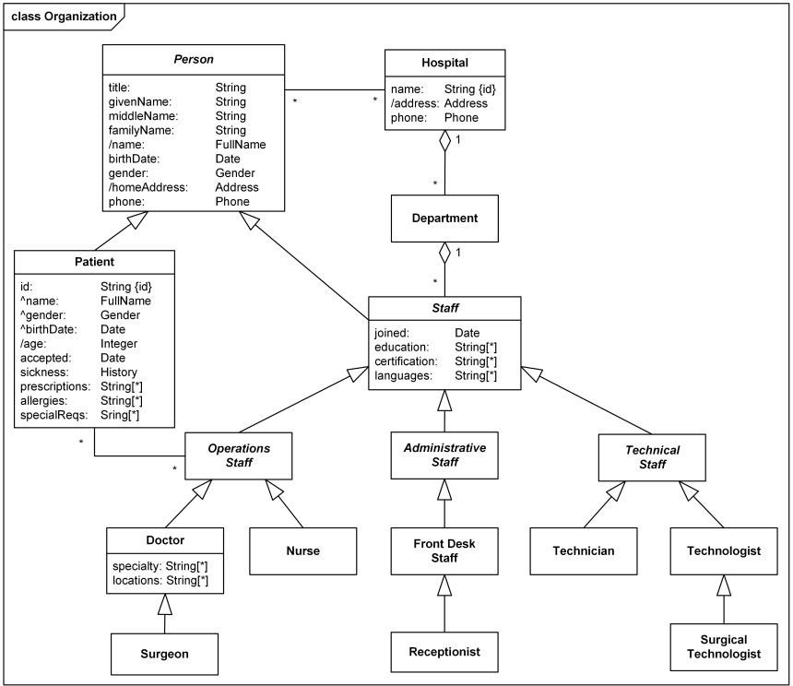**2 Class –Example-Hospital-Orgnization**

* 1. **Use Case Diagrams**

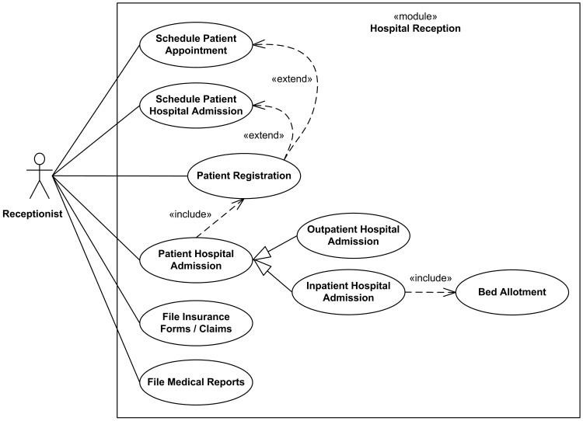

Login

Password

Gmail

Doctor

Admin

* 1. **Module Hierarchy Diagram**

Feedback

Bill

Department

Nurse

Patient

Online Hospital Management System

* 1. **Component Diagram**

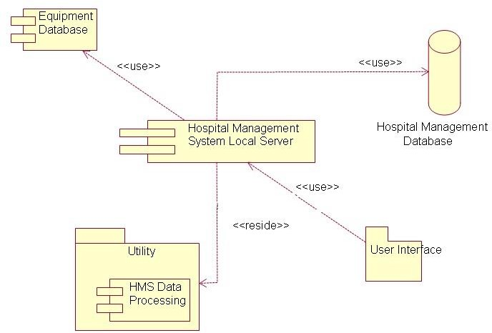

* 1. **Deployment Diagram**

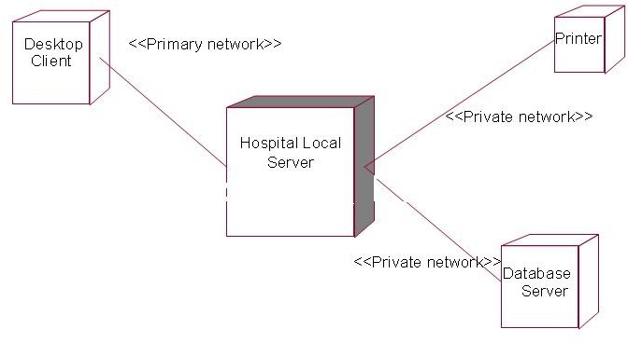

* 1. **Module Specifications**

|  |  |
| --- | --- |
| User | Someone who interacts with the mobile phone  ,website and computer system |
| Admin/Administrator | System administrator who is given specific  permission for managing and controlling the system |
| Appointment | Someone who has take appointment of particular doctor. |
| Department | Departments include the information about the hospital. |
| Facility | Facility shows the facilities available in the  hospital. |
| Contact Us | User Contact information stores on the website |
| Feedback | Users Gives Feedback about the hospital  facilities provided to patients. |
| Patient | Who take the appointment of particular  disease doctor. |
| Doctor | Enter doctor details in the database |
| Reports | There are various reports in the system.   1. Appointment report 2. Doctor List report 3. Patient List report 4. Doctor wise Appointment report 5. report 6. Registration report 7. Feedback Report 8. Doctor Details report |

* 1. **User Interface Design:**

###### Context level DFD:

Personal Details

OPD

0 Level

Bill Report

Online Hospital Management

System

Bill Genrate

Patient

Admin

Patient

Admin

* + 1. First Level DFD:

Persnal Detail of Patient Update

1.0

Admin

Patient Detail

Patient db

Persnal Detail of Doctor

Admin

2.0

Doctor Details

Update

Update

Doctor db

Patient details

3.0 Lab Report Generation

Update

Reports db

4.0 Bill Generation

Discharge

Doctor name & fees Patient Detail

##### ER Diagram

1

fill

Doctor

Login

1

1

does

1

1

1

1

l

give

read

ogin

1

1

read

Feedback

1

1

1

1

read

manag

manag

1

1

manag

1

manage

add

1

manage

Appointmen

Admin

Facility

ct Us

Conta

Registration

User

ut Us

Abo

##### Sequence Diagram

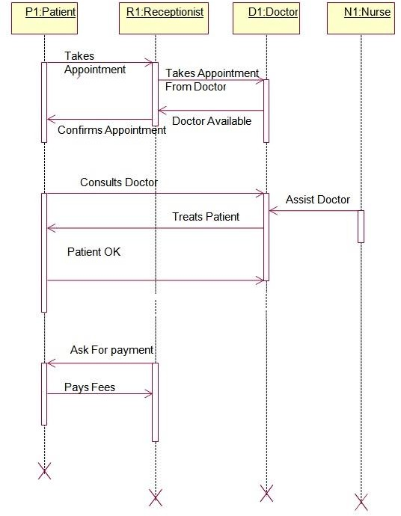

* 1. **State Diagram**

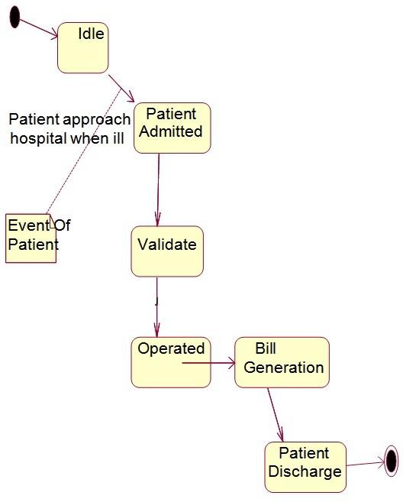

* 1. **ActivityDiagram**

Patient Doctor

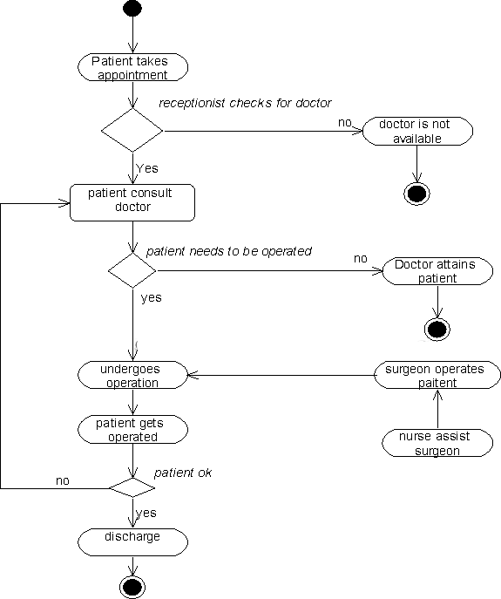

* 1. **Table Specification:**

1. AdminForm

|  |  |  |  |
| --- | --- | --- | --- |
| Sr.No | Name | Data type | Key |
| 1 | Email | Text | - |
| 2 | Mobile | Password | - |

1. Department List Form

|  |  |  |  |
| --- | --- | --- | --- |
| Sr.No | Name | Data type | Key |
| 1 | Department ID | Int | - |
| 2 | Department name | Varchar | - |
| 3 | Department discription | Varchar |  |

1. Doctor List Form

|  |  |  |  |
| --- | --- | --- | --- |
| Sr.No | Name | Data type | Key |
| 1 | Doctor ID | Int | - |
| 2 | Doctor name | Varchar | - |
| 3 | Department | Varchar |  |
| 4 | Phone no | int |  |

1. Edit Doctor Form

|  |  |  |  |
| --- | --- | --- | --- |
| Sr.No | Name | Data type | Key |
| 1 | Doctor ID | Int |  |
| 2 | Name | Varchar | - |
| 3 | Email | Varchar |  |
| 4 | Password | int |  |
| 5 | Address | Text |  |
| 6 | Phone | Varchar |  |
| 7 | Department | Text |  |

1. Patient List Form

|  |  |  |  |
| --- | --- | --- | --- |
| Sr.No | Name | Datatype | Key |
| 1 | ID | Int |  |
| 2 | Patient Name | Varchar | - |
| 3 | Age | int | - |
| 4 | Sex | Varchar | - |
| 5 | Blood Group | Varchar | - |

1. Nurse List Form

|  |  |  |  |
| --- | --- | --- | --- |
| Sr.No | Name | Datatype | Key |
| 1 | Nurse ID | Int |  |
| 2 | Nurse Name | Varchar | - |
| 3 | Email | Varchar | - |
| 4 | Address | Varchar | - |
| 5 | Phone No | int | - |

1. Doctor Dashboard Form

|  |  |  |  |
| --- | --- | --- | --- |
| Sr.No | Name | Datatype | Key |
| 1 | Apointment ID | Int |  |
| 2 | Name | Varchar | - |
| 3 | Email | Varchar |  |
| 4 | Contact | int |  |
| 5 | Age | int |  |
| 6 | Day | Varchar | - |
| 7 | Speciality | Varchar | - |
| 8 | Description | Varchar | - |
| 9 | Id | int |  |
| 10 | Action | Varchar |  |

1. Registration Form

|  |  |  |  |
| --- | --- | --- | --- |
| Sr.No | Name | Key | Key |
| 1 | RID | Auto Number | Primary Key |
| 2 | Name | Short Text |  |
| 3 | Phone | Short Text |  |
| 4 | Address | Short Text |  |
| 5 | Gender | Short Text |  |
| 6 | Age | Short Text |  |
| 7 | Password | Short Text |  |

**3.13 Test Procedures and Implementation**

**Test Procedure:**

The importance of software testing and its implication with respect to software quality cannot be over emphasized. Software testing is typical element of software quality assurance. Testing represents the ultimate review of specification, design and coding.

Any engineered product can test in one of two ways :

The First approach is called **Black Box Testing** and the second one is called as **White Box Testing:**

When computer software is considered, Black Box Testing alludes to test that is conducted at the software interface. Although they are designed to uncover errors, Black Box Test are used to demonstrate that software functions are operational that input properly accepted and output correctly produced; that integrity of external information is maintained. Black Box Test examines some aspects of system with little regard for internal structure of software. White Box testing of software is predicted on a close examination of procedural details. Providing test cases that exercise specific sets of conditions and /or loops test logical paths through software.

Test Plan:

The Test Plan is designed to describe the scope, approach, resources, and schedule of all testing activities. The Test plan identifiesthe items to be tested like Authentication, the features to be tested like (for Authentication module) whether user is having privilege to login to the system or not, the types of testing to be performed like Unit Testing, Security Testing, User Interface Testing, Performance Testing, Regression Testing, the resources required to perform testing.

Unit/Module Testing:

Testing conducted to verify the implementation of the design for one software element (e.g., unit, module) is called unit testing. The purpose of unit testing

is to ensure that the program logic is complete and correct and ensuring that the component works as designed.

In each module will be go through Unit testing after the completion of the module. The bugs in module testing will be reported in Test Log document and will be reported to the developers.

After fixing the bug successfully, one more iteration of module testing (Regression Testing) is done. This process is repeated till all critical test cases pass.

Integration Testing:

Testing conducted in which software elements, hardware elements, or both are combined and tested until the entire system has been integrated. The purpose of integration testing is to ensure that design objectives are met and ensures that the software, as a complete entity, complies with operational requirements. This type of testing will be done after all module test cases are passed through module testing, security testing, performance testing, user interface testing and regression testing.

User Interface Testing:

Testing done to ensure that the application operates efficiently and effectively on each client machine

Security Testing:

In Authentication component, user needs to enter his login id and password. If the user name and password is valid then user is allowed to log in. As per the role of user will get the access over the different options

Regression Testing:

Testing done to ensure that, the changes to the application has not adversely affected previously tested functionality. In Effort tracking system, testing will take care of the test cases passed during the first module testing will not be affected in the subsequent rounds of module testing.

Acceptance Testing:

This testing is conducted to determine whether the product satisfies the acceptance criteria of the user. It enables the customer to determine whether or not to accept the system. Acceptance testing ensures that customer requirements are met.

Beta Testing:

Testing, done by the customer, using a pre-release version of the product to verify and validate that the system meets business functional requirements. The purpose of beta testing is to detect application faults, failures, and defects in application on regular worked basis. The Consistent performance of whole product will be tested for period of time to ensure that the product is ready in release stage.

Tools:

Testing is performed manually without using any automated tools.

Test cases:

**Test cases:1**

|  |  |  |  |  |  |  |
| --- | --- | --- | --- | --- | --- | --- |
| Id | Scenario | Sr No | Action | Expected Output | Actual output | Result |
| 1 | Registrati on | A | User keeps the name field blank  User enters digits in user name fields | Message window saying “Name is Required.”  Message window saying “ Name Must be Alphabate or greater then 3 alphabets” | Message window saying “ Name is Required.”  Message window saying “ Name Must be Alphabet or greater then 3 alphabets” | PASS |
|  |  | B | User keeps mobile number field blank  User enters alphabet in mobile no fields or less than 10 digits or greater than 10 digits | Message window saying “Mobile Number is Required.”  Message window saying “ Mobile Number Must be 10 digit or digits only ” | Message window saying “Mobile Number is Required.”  Message window saying “ Mobile Number Must be 10 digit or digits only ” | PASS |
|  |  | C | User keeps address field blank  User enter special symbols in address field | Message window saying “Address is Required.”  Message window saying “Only number and digit allowed.” | Message window saying “Address is Required.”  Message window saying “Only number and digits allowed.” | PASS |

|  |  |  |  |  |  |  |
| --- | --- | --- | --- | --- | --- | --- |
|  |  | D | User keeps gender field blank | Message window saying “Gender is Required.” | Message window saying “Gender is Required.” | PASS |
|  |  | E | User keeps age field blank  User enter alphabet in age | Message window saying “Age is Required.”  Message window saying “Age must be between 1 to 100 must be number.” | Message window saying “Age is Required.”  Message window saying “Age must be between 1 to 100 must be number.” |  |
|  |  | F | User keeps password field blank  User enters only alphabets or digits in password field | Message window saying “Password is Required.”  Message window saying “Must contain at least one number and one uppercase and lowercase letter, and at least 8 or more characters.” | Message window saying “Password is Required.”  Message window saying “Must contain at least one number and one uppercase and lowercase letter, and at least 8 or more characters.” | PASS |

**Test cases:2**

|  |  |  |  |  |  |  |
| --- | --- | --- | --- | --- | --- | --- |
| Id | Scenario | Sr No | Action | Expected Output | Actual output | Result |
| 1 | Login | A | User | Message window | Message window | PASS |
|  |  |  | submits | saying “Invalid | saying “Invalid |  |
|  |  |  | without | Login.” | Login.” |  |
|  |  |  | entering |  |  |  |
|  |  |  | username |  |  |  |
|  |  | B | User | Message window | Message window | PASS |
|  | submits | saying “Invalid | saying “Invalid |  |
|  | without | Login.” | Login.” |  |
|  | entering |  |  |  |
|  | password |  |  |  |
|  |  | C | User | Message window | Message window | PASS |
|  | submits | saying “Invalid | saying “Invalid |  |
|  | with | Login.” | Login.” |  |
|  | either or |  |  |  |
|  | both user |  |  |  |
|  | name & |  |  |  |
|  | password |  |  |  |
|  | being |  |  |  |
|  | wrong |  |  |  |
|  |  | D | User | Message window | Message window | PASS |
|  | enters | saying “ Login.” | saying “ Login.” |  |
|  | correct | Takes username | Takes username to |  |
|  | user name | to corresponding | corresponding |  |
|  | and | home page. | home page. |  |
|  | password. |  |  |  |

**Test cases:3**

|  |  |  |  |  |  |  |
| --- | --- | --- | --- | --- | --- | --- |
| Id | Scenario | Sr No | Action | Expected Output | Actual output | Result |
| 1 | Contact Us | A | User keeps the name field blank  User enters digits in user name fields | Message window saying “Name is Required.”  Message window saying “ Name Must be Alphabate or greater then 3 alphabets” | Message window saying “Name is Required.”  Message window saying “ Name Must be Alphabate or greater then 3 alphabets” | PASS |
|  |  | B | User keeps the email field blank  User keeps the email fields blank and domain name is more than 4 or less  than 2 | Message window saying “Email is Required.”  Message window saying “Invalid Email.” | Message window saying “Email is Required.”  Message window saying “Invalid Email.” | PASS |
|  |  | C | User keeps the message field blank  User enters digits in  message fields | Message window saying “Message is Required.”  Message window saying “ Message Must be Alphabate or greater then 3 alphabets” | Message window saying “ Message is Required.”  Message window saying “ Message Must be Alphabate or greater then 3 alphabets” | PASS |

**Test cases:4**

|  |  |  |  |  |  |  |
| --- | --- | --- | --- | --- | --- | --- |
| Id | Scenario | Sr No | Action | Expected Output | Actual output | Result |
| 1 | Feedback | A | User keeps the name field blank  User enters digits in user name fields | Message window saying “Name is Required.”  Message window saying “ Name Must be Alphabate or greater then 3 alphabets” | Message window saying “ Name is Required.”  Message window saying “ Name Must be Alphabet or greater then 3 alphabets” | PASS |
|  |  | B | User keeps mobile number field blank  User enters alphabet in mobile no fields or less than 10 digits or greater than 10 digits | Message window saying “Mobile Number is Required.”  Message window saying “ Mobile Number Must be 10 digit or digits only ” | Message window saying “Mobile Number is Required.”  Message window saying “ Mobile Number Must be 10 digit or digits only ” | PASS |
|  |  | C | User keeps address field blank  User enter special symbols in address field | Message window saying “Address is Required.”  Message window saying “Only number and digit allowed.” | Message window saying “Address is Required.”  Message window saying “Only number and digits allowed.” | PASS |

|  |  |  |  |  |  |  |
| --- | --- | --- | --- | --- | --- | --- |
|  |  | D | User | Message window | Message window | PASS |
|  | keeps | saying “Gender is | saying “Gender is |  |
|  | gender | Required.” | Required.” |  |
|  | field |  |  |  |
|  | blank |  |  |  |
|  |  | E | User keeps age field blank  User enter alphabet in age | Message window saying “Age is Required.”  Message window saying “Age must be between 1 to 100 must be number.” | Message window saying “Age is Required.”  Message window saying “Age must be between 1 to 100 must be number.” |  |
|  |  | F | User keeps the comment field blank  User enters digits in comment fields | Message window saying “comment is Required.”  Message window saying “comment Must be Alphabate or greater then 3 alphabets” | Message window saying “comment is Required.”  Message window saying “comment Must be Alphabate or greater then 3 alphabets” | PASS |

**Test cases:5**

|  |  |  |  |  |  |  |
| --- | --- | --- | --- | --- | --- | --- |
| Id | Scenario | Sr No | Action | Expected Output | Actual output | Result |
| 2 | Doctors Details | A | User keeps the doctor name field blank  User enters digits in user doctor name fields | Message window saying “Doctor Name is Required.”  Message window saying “ Doctor Name Must be Alphabate or greater then 3 alphabets” | Message window saying “Doctor Name is Required.”  Message window saying “ Doctor Name Must be Alphabate or greater then 3 alphabets” | PASS |
|  |  | B | User keeps the qualificati on field blank  User enters digits in user qualificati on fields | Message window saying “qualification is Required.”  Message window saying “ qualification Must be Alphabate or greater then 3 alphabets” | Message window saying “qualification is Required.”  Message window saying “ qualification Must be Alphabate or greater then 3 alphabets” | PASS |
|  |  | C | User keeps the specialty field blank  User enters digits in user specialty fields | Message window saying “specialty is Required.”  Message window saying “ specialty Must be Alphabate or greater then 3 alphabets” | Message window saying “specialty is Required.”  Message window saying “ specialty Must be Alphabate or greater then 3 alphabets” | PASS |



USER MANUAL

**4.1 User manual**

User Manual will help walk Eligible Hospitals through the following steps:

* How to create aSLR account.
* How to access the SLR application

.•How to register for the provider incentive program.

* How to enter the eligibility information for the provider incentive program.
* How to enter theattestation for the certified Electronic Health Record (EHR) technology.
* How to submit the finalattestation.
* How to make changes to anaccount.
* Who to call for technical assistance

1. Anyone can visit website
2. This website give information about hospital and online appointment.
3. When you want to take appointment then you must registration and login into the website.



PROPOSED SYSTEM ENHANCEMENT

The Proposed System is hospital management system.we can enhance this System by including more facilities like binding system,inpatient room allotment for the admitted patients and the stock details of medicines in the pharmacy.Providing such features enable the users to include more comments into the system.

1. We Can add Printer in future.
2. We can give more advance software for hospital management system including more facilities.

3.we will host the platform on online servers to make it accessible worldwide 4.Integrate multiple load balancer to distribute the loads of the system.

1. Create the master and slave database structure to reduce the overload of the database queries.
2. Implement the backup mechanism for taking backup of codebase and database on regular basis on different servers.

The above mentioned points are the enhancements which can be done to increase the applicability and usages of this projects . Here we can maintain the records of Hospital and Doctors. Also as it can be seen that now –a-days the players are versatile, i.e. so there is a scope for introducing a method to maintain the hospital management system. Enhancement can be done to maintain all the Hospital, Doctors, Patient, Employee, Test.



Drawbacks & Limitation

* 1. Only appointments are taken in that website.
  2. All information about the hospital are not mention in that website.
  3. The size of the database increases day-by-day, increasing the load on the database back up and data maintenance activity.
  4. Training for simple computer operations is necessary for the users working on the system.
  5. Excel export has not been developed for Hospital ,Doctors due to some criticality.
  6. The transaction are executed in off-line mode, hence on-line data for Patient,Employee capture and modification is not possible.
  7. Off-line reports of Hospital,Test,Patient cannot be generated due to batch mode execution.



CONCLUSION

The Online Hospital management System is the great improvement over the manual System using the case fields and paper .The computerization of the system has sped up the process in the current system ,the front office managing is very Slow The hospital managing system was throughtly checked and tested with dummy data and thus is found to be very reliable

Our project is only a humble venture to satisfy the needs to manage their project work. Several user friendly coding have also adopted .this package shall prove to be a powerful package in satisfying all the requirements of the school. The objective of software planning is to provide a frame work that enables the manager to make reasonable estimates made within a limited time frame at the beginning of the software project and should be updated regularly as the project progresses.

At the end it is concluded that we have made effort on following points.

* A description of the background and context of the project and its relation to work already done in the area.
* Made statement of the aims and objectives of the project.
* The description of Purpose, Scope, and applicability.
* We define the problem on which we are working in the project.
* We describe the requirement specification of the system and the actions that can be done on these things.
* We understand the problem domain and produce a model of the system,which describes operations that can be performed on the system.
* We included features and operations in detail,including screen layouts.
* We designed user interface and security issues related to system.
* Finally the system is implemented and tested according to test cases.



BIBLOGRAPHY

**BOOKS:**

JAVA–The Complete reffernce. AIT –Complete Reffernce

**ONLINE REFERENCE**

* + 1. [www.google.com](http://www.google.com/)
    2. [www.guru99.com](http://www.guru99.com/)
    3. [www.codeproject.com](http://www.codeproject.com/)
    4. [www.stackoverflow.com](http://www.stackoverflow.com/)



**ANNEXURE 1 (USER INTERFACE SCREENS)**

1. Admin Login

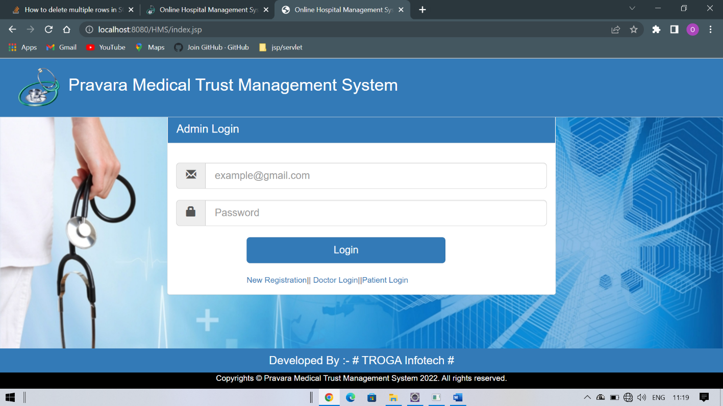

1. Admin HomePage

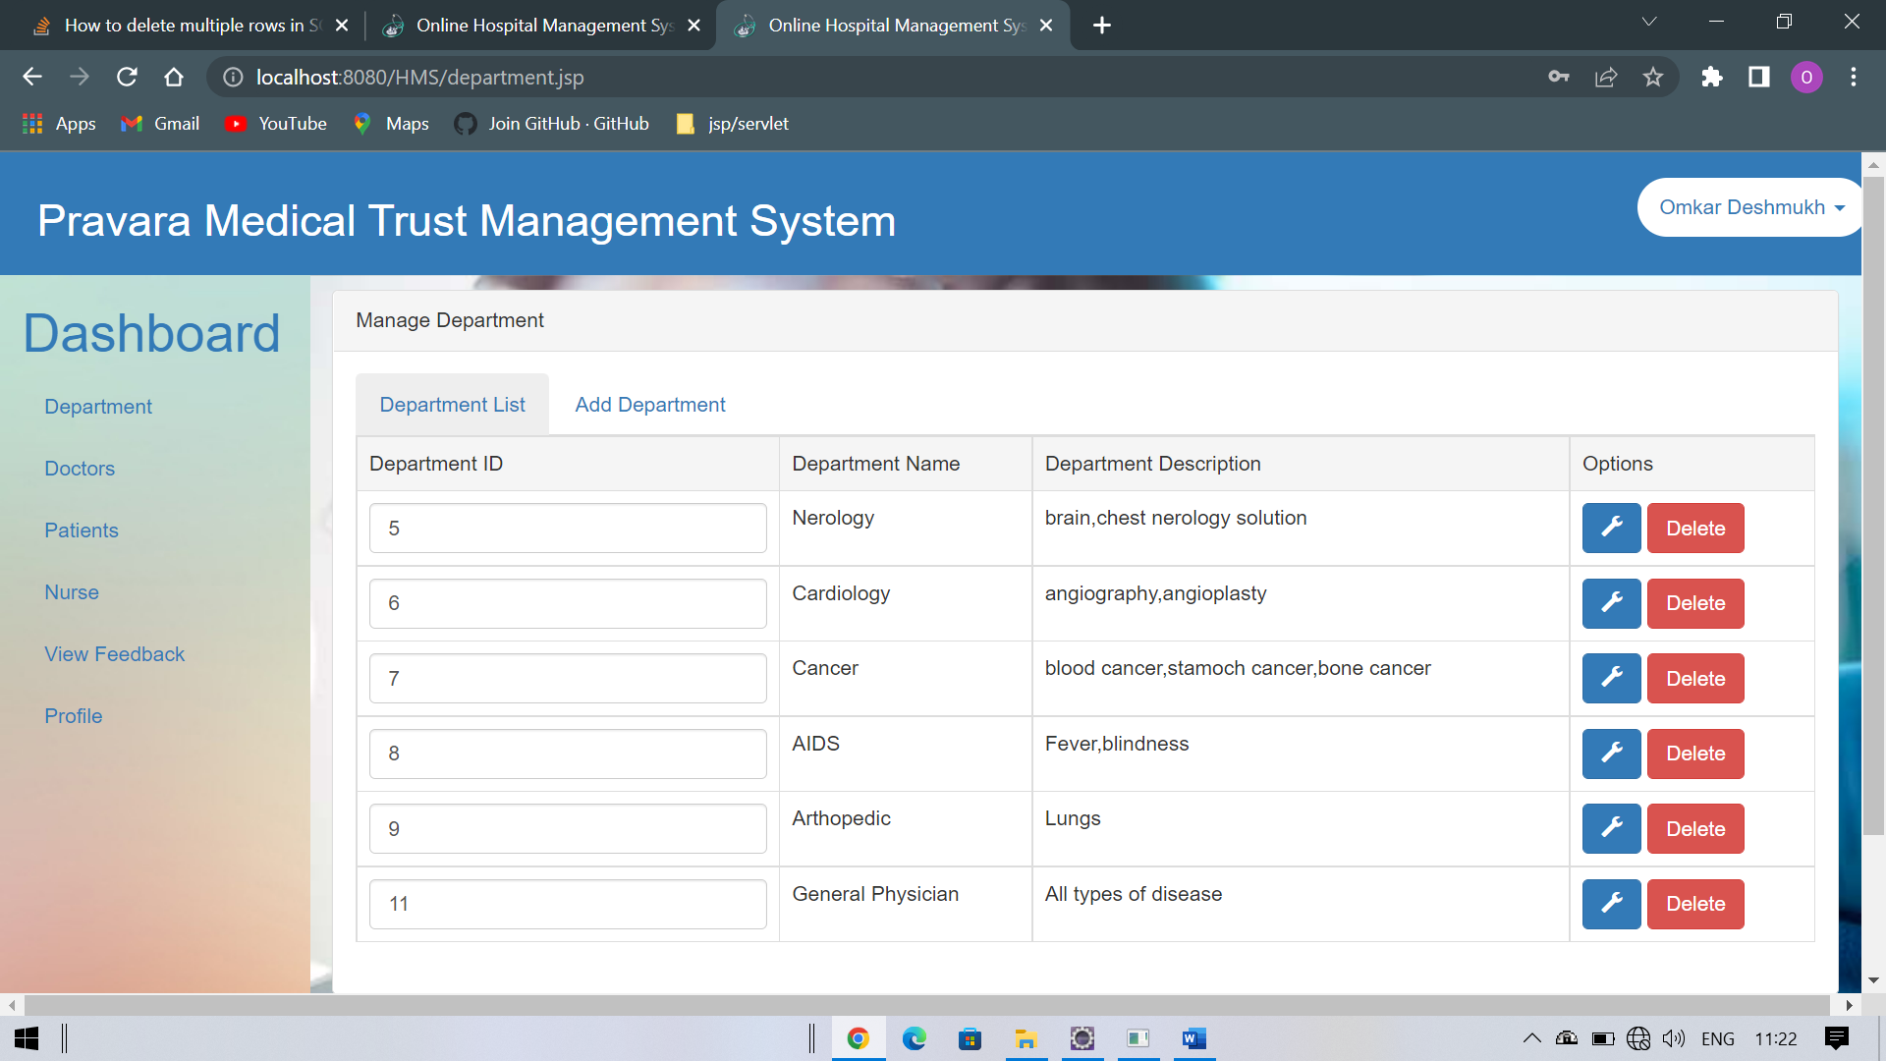

1. Edit Department

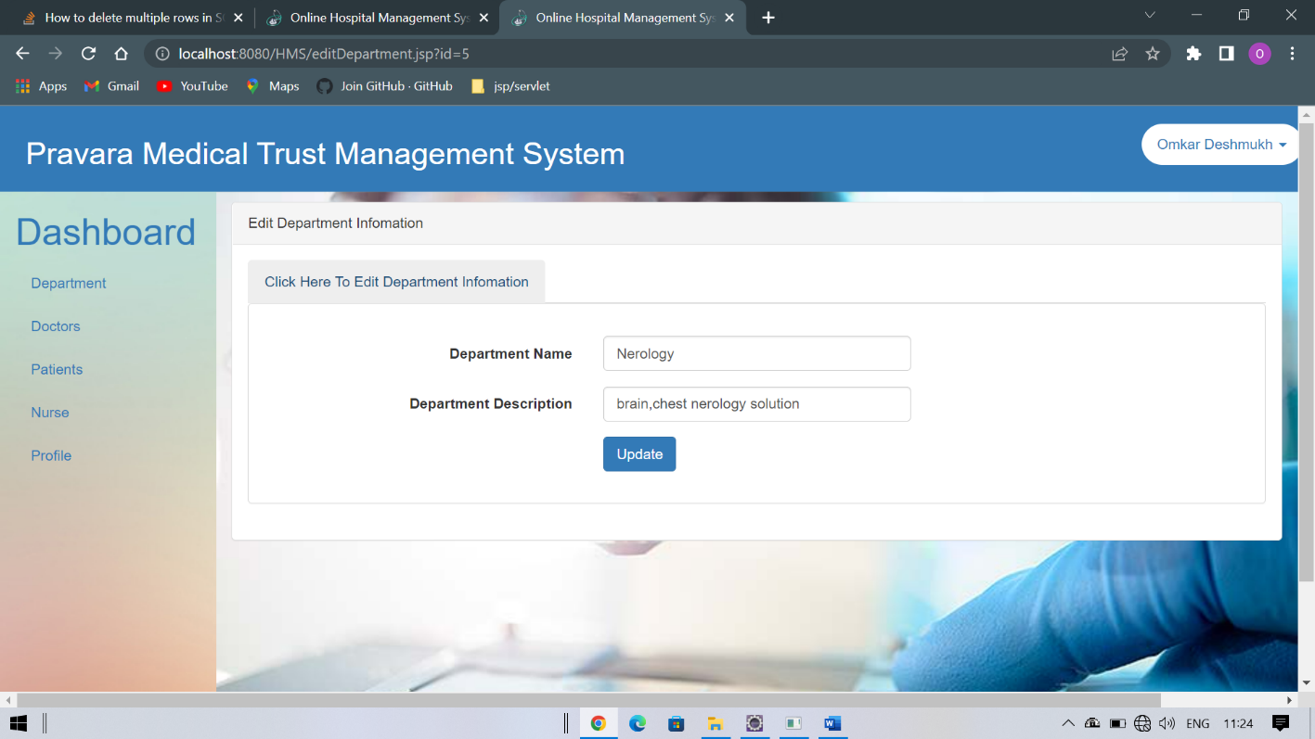

1. Add Department

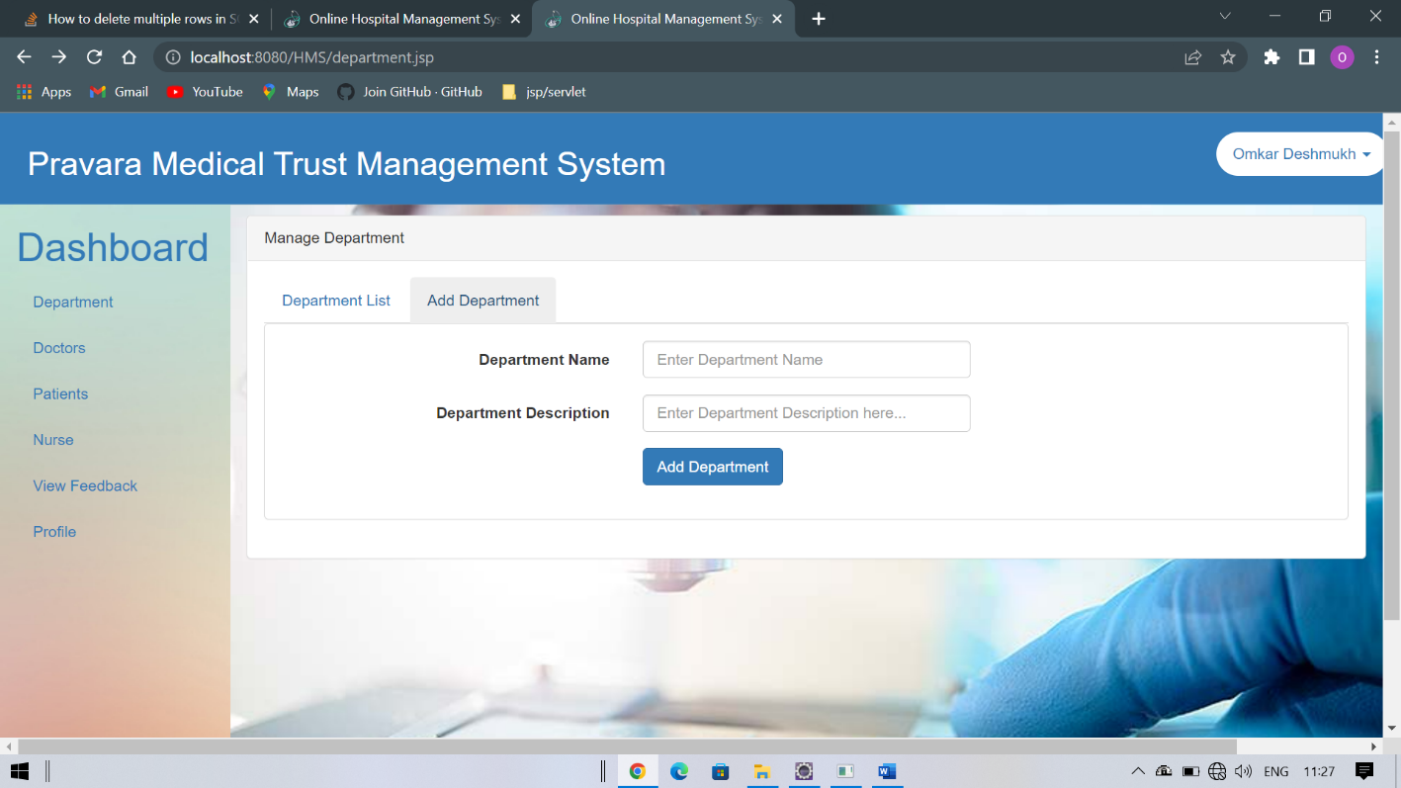

1. All Department

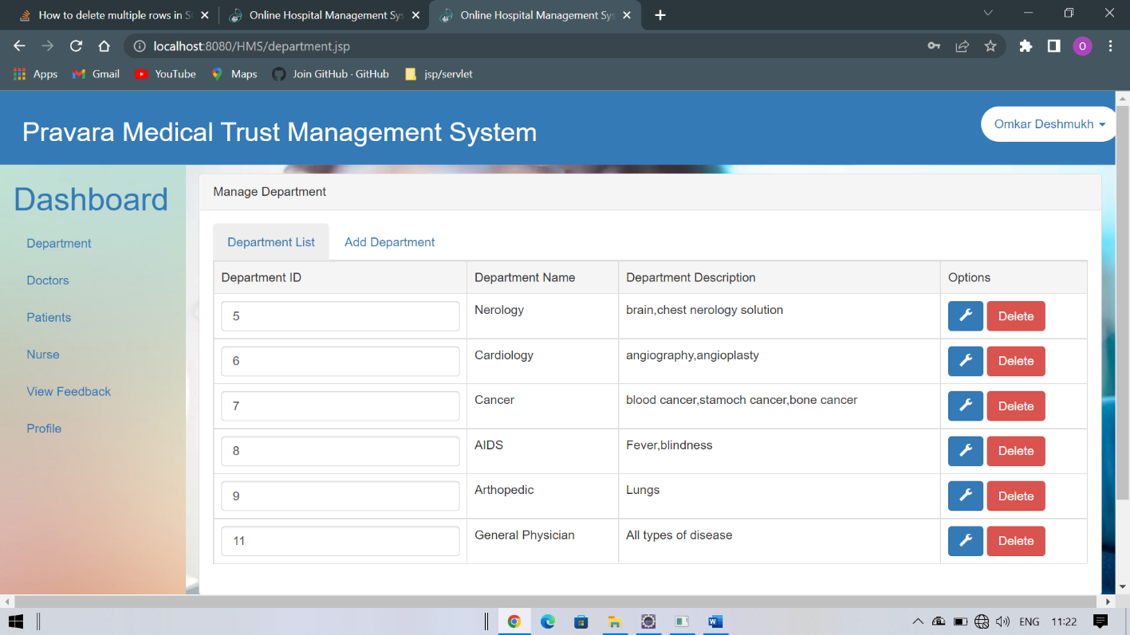

1. Update Doctor

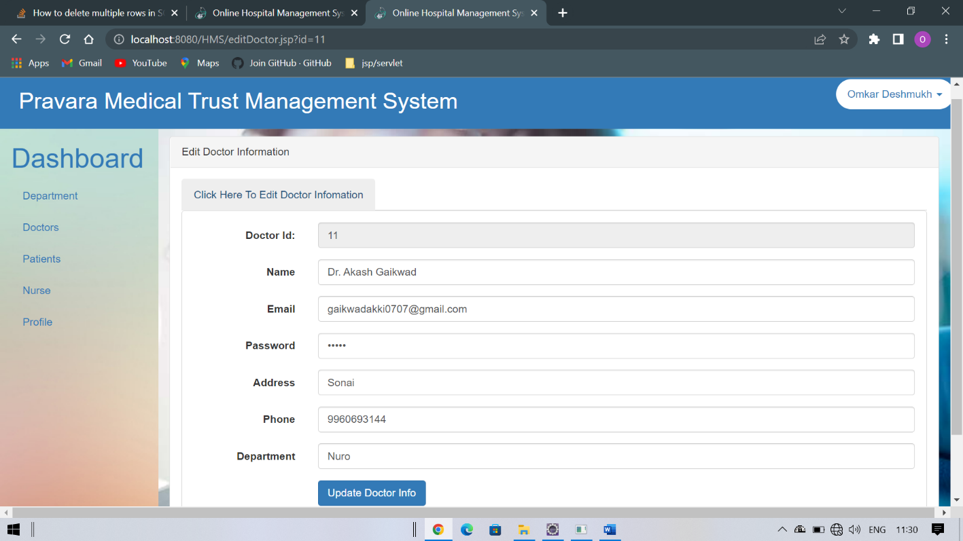

1. Add New Doctor

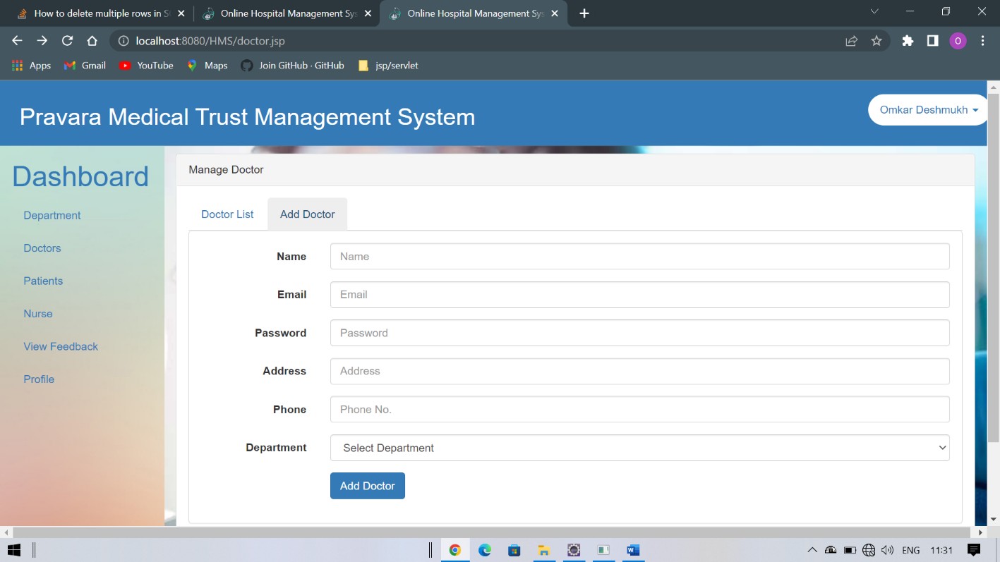

1. Patient List

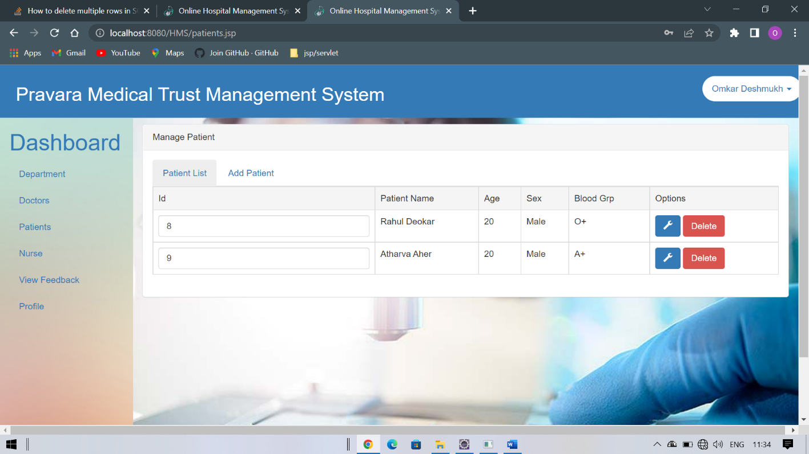

1. Add New Patient input form

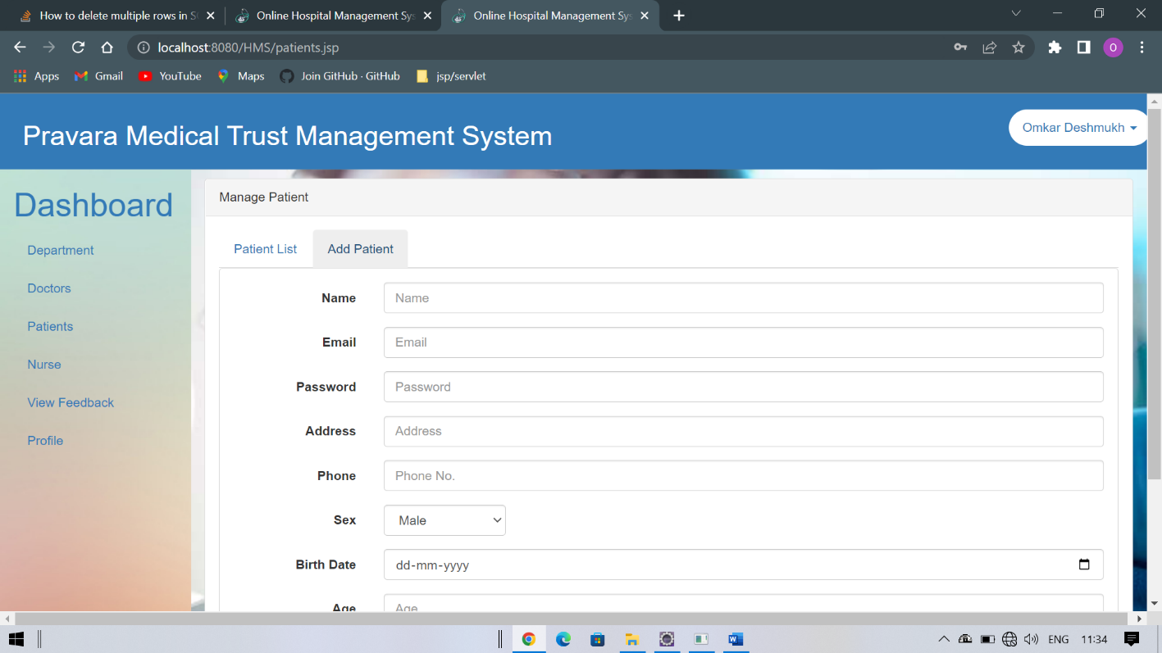

1. Feedback Details

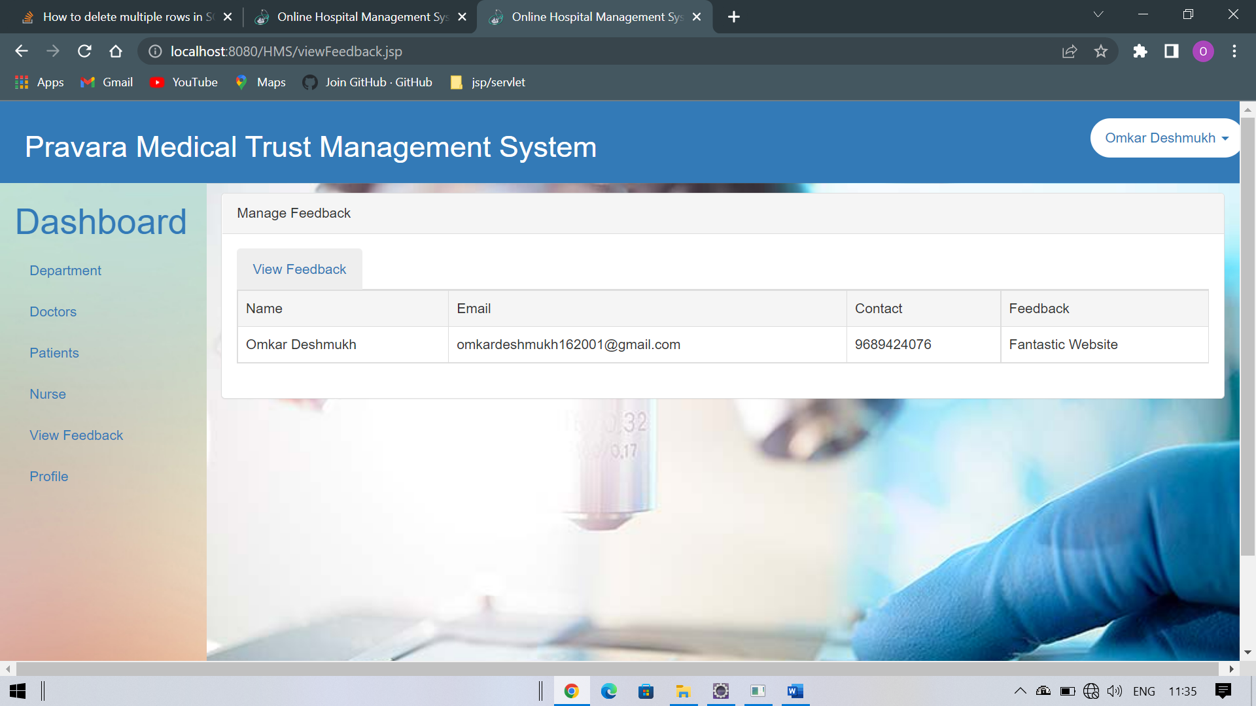

1. Profile Updation/Password Updation

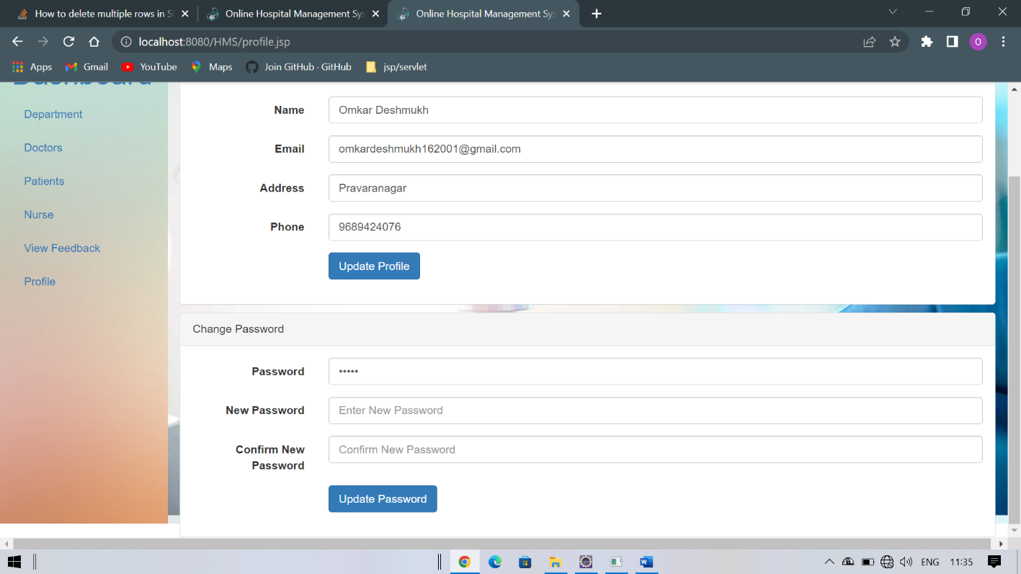

12..All Nurse Details

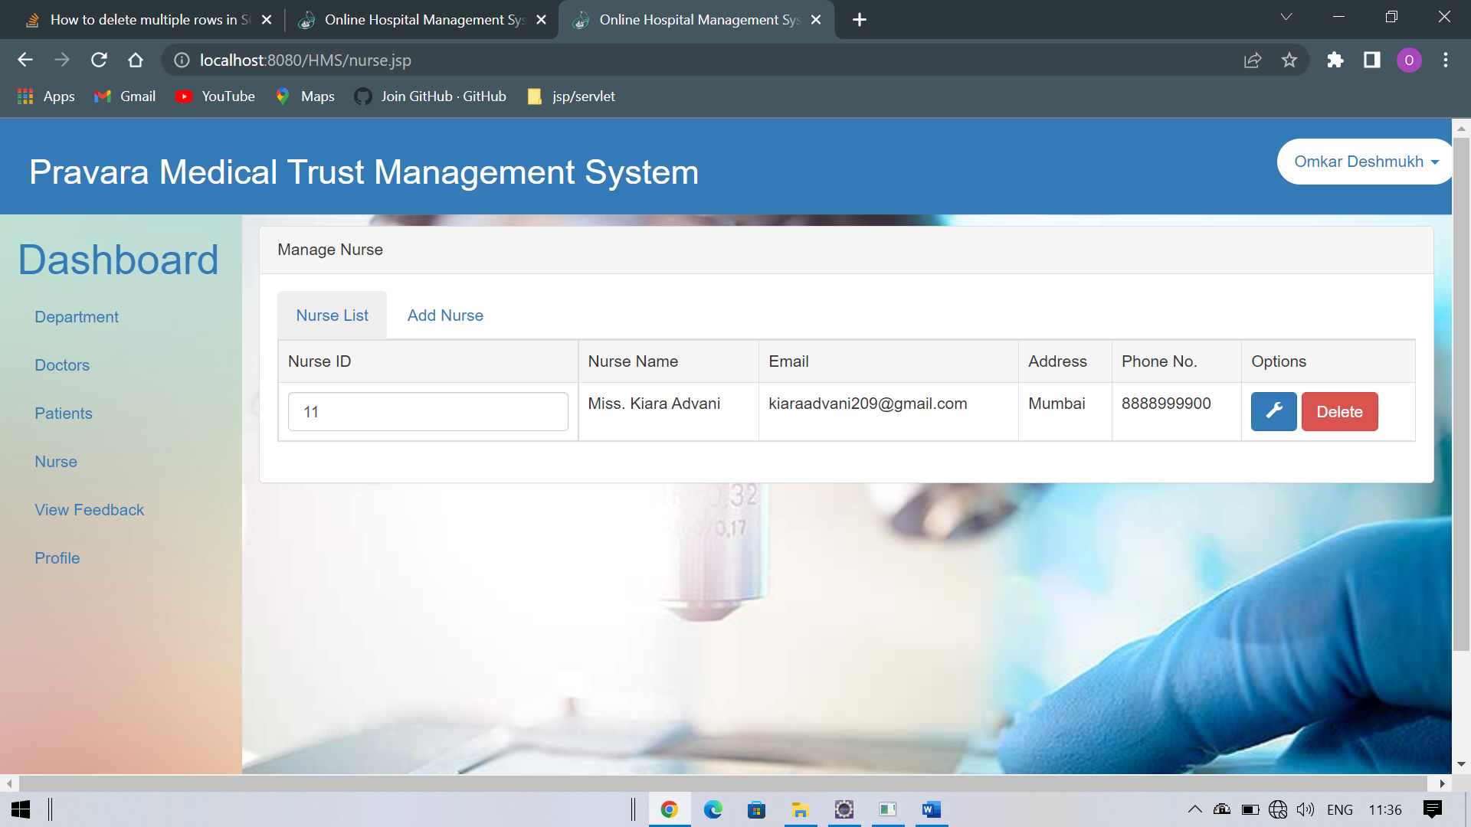

1. Doctor Login

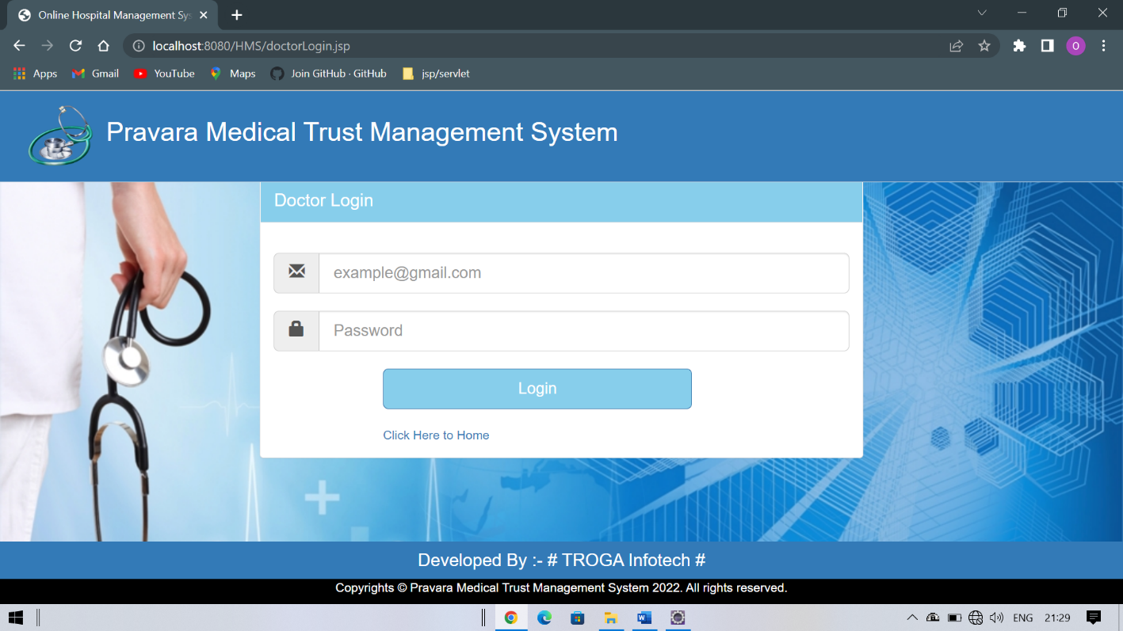

1. Doctor Profile Updation

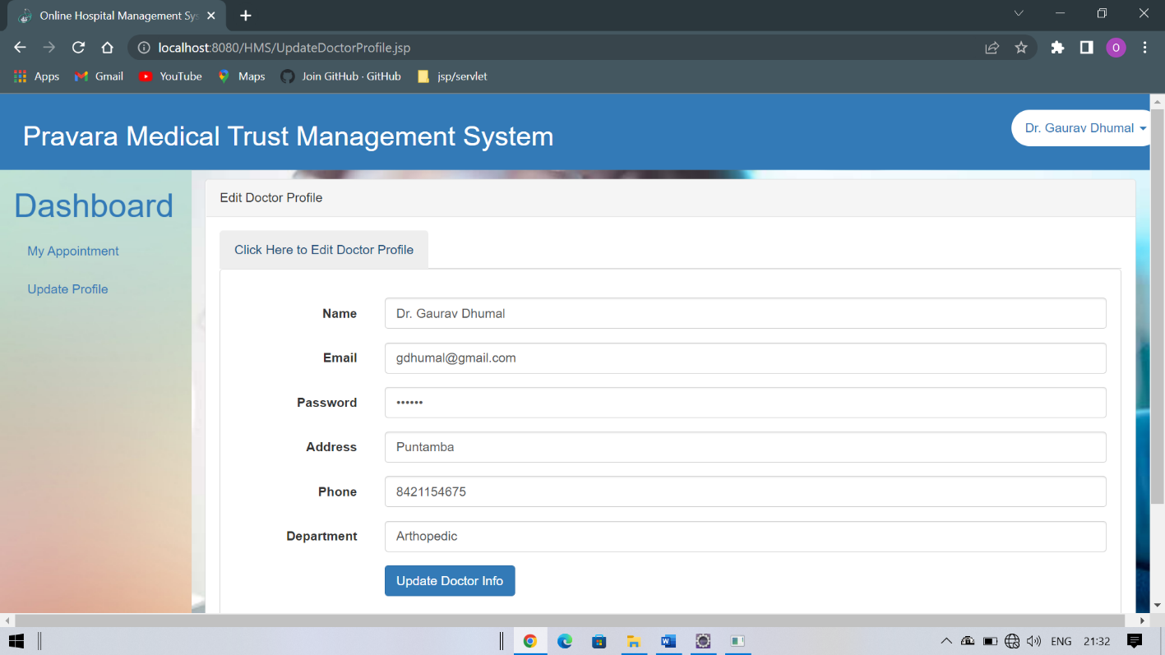



**ANNEXURE 2 (OUTPUT REPORTS WITH DATA)**

* 1. Doctor List

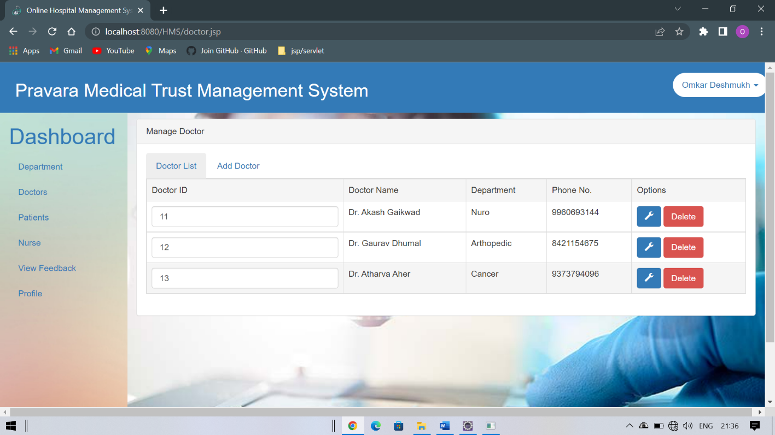

* 1. Patient List

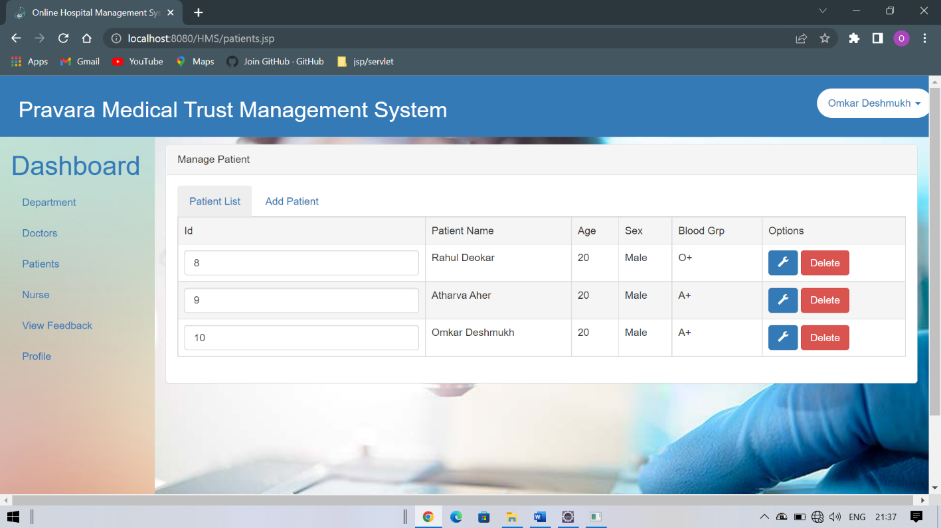

* 1. Nurse List

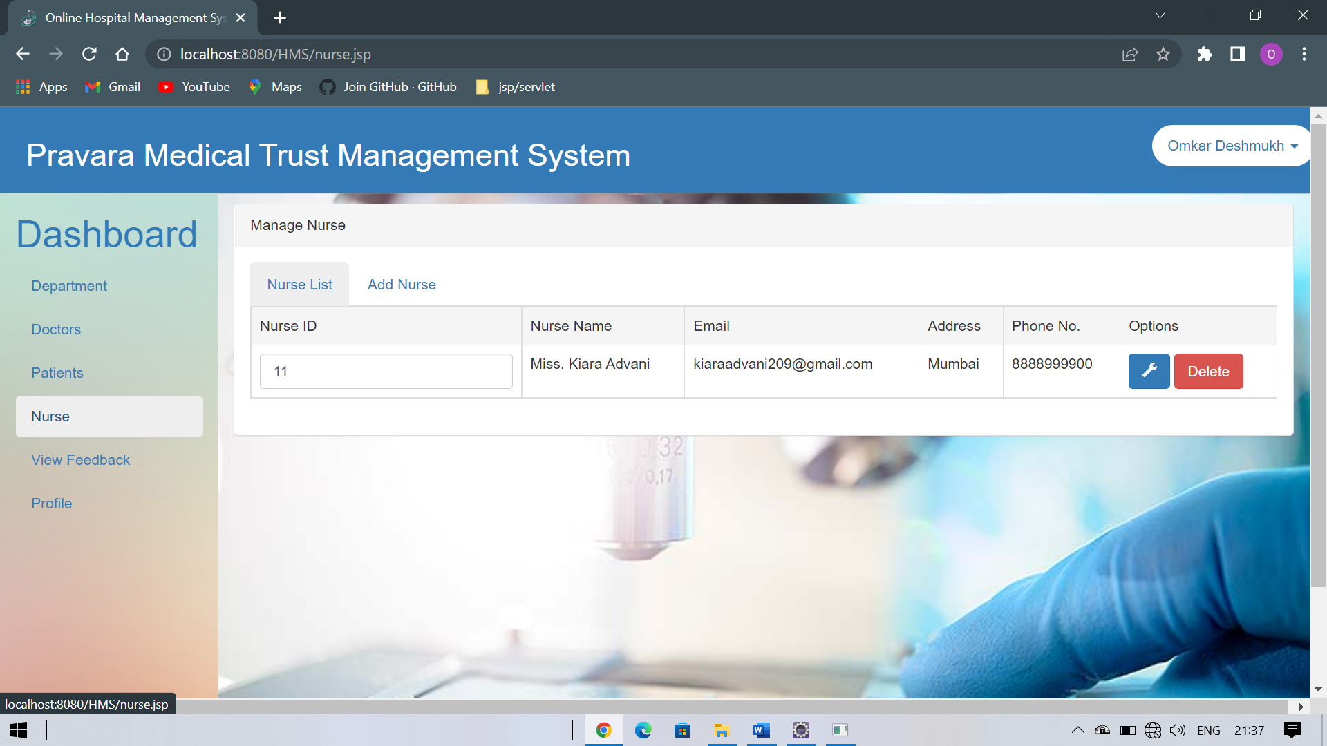

* 1. Department

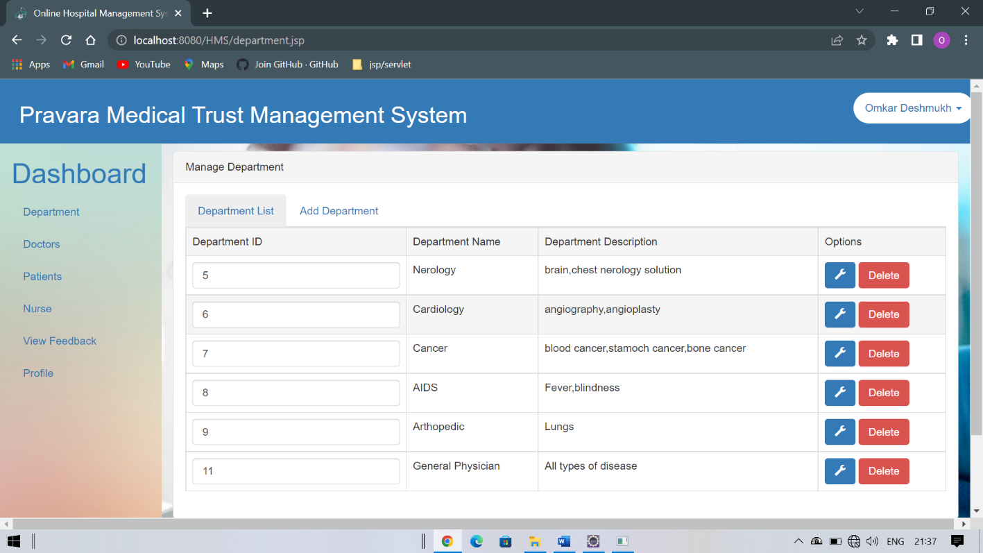



**ANNEXURE 3 (SAMPLE CODE)**

##### Login Form

**After Patient Login.jsp**

<%@ page language=*"java"* contentType=*"text/html; charset=ISO-8859-1"*

pageEncoding=*"ISO-8859-1"*%>

<%@ page import=*"java.sql.*"*%>

<%@ page import=*"com.connection.*"*%>

<%@ page import=*"com.bean.Appointment"*%>

<%@page import=*"java.util.*"*%>

<!DOCTYPE html>

<html lang=*"en"*>

<head>

<meta charset=*"utf-8"*>

<meta http-equiv=*"X-UA-Compatible"* content=*"IE=edge"*>

<meta name=*"viewport"* content=*"width=device-width, initial-scale=1"*>

<link href=*"images/logo.png"* rel=*"icon"* />

<title>Online Hospital Management System</title>

<!-- Bootstrap -->

<link href=*"css/bootstrap.min.css"* rel=*"stylesheet"*>

<link href=*"css/style.css"* rel=*"stylesheet"*>

<script src=*"js/jquery.js"*></script>

<script type=*"text/javascript"*>

$(document).ready(**function**() {

$('#doctorlist').show();

$('.doctor li:first-child a').addClass('active');

$('.doctor li a').click(**function**(e) {

**var** tabDiv = **this**.hash;

$('.doctor li a').removeClass('active');

$(**this**).addClass('.active');

$('.switchgroup').hide();

$(tabDiv).fadeIn(); e.preventDefault();

});

});

</script>

</head>

<body>

<div class=*"container-fluid"*>

<!--- Header Start >

<div class=*"row header"*>

<div class=*"col-md-10"*>

</div>

<h2>Ghati Hospital Mangement System</h2>

class=*"dropdown-toggle"* haspopup=*"true"*

<div class=*"col-md-2 "*>

<ul class=*"nav nav-pills "*>

<li class=*"dropdown dmenu"*><a href=*"#"*

data-toggle=*"dropdown"* role=*"button"* aria- aria-expanded=*"false"*> <%

out.print((String) session.getAttribute("uname"));

%> <span class=*"caret"*></span>

Profile</a></li> class=*"divider"*></li> href=*"logout.jsp"*>Logout</a></li>

</a>

<ul class=*"dropdown-menu "*>

<li><a href=*"profile.jsp"*>Change

<li role=*"separator"*

<li><a

</div>

</div>

</ul>

</ul></li>

<!--- Header Ends >

<%

!= "") {

**if** (session.getAttribute("uname") != **null** && session.getAttribute("uname")

%>

<div class=*"row"*>

<!----- Menu Area Start >

<div class=*"col-md-2 menucontent"*>

<a href=*"#"*><h1>Dashboard</h1></a>

href=*"afterPatientLogin.jsp"*>Book

<ul class=*"nav nav-pills nav-stacked"*>

<li role=*"presentation"*><a

An Appointment</a></li>

<li role=*"presentation"*><a

href=*"updatePatientProfile.jsp"*>Update

href=*"viewAppointment.jsp"*>View href=*"feedback.jsp"*>Feedback</a></li>

</ul>

Profile</a></li>

<li role=*"presentation"*><a

Appointment</a></li>

<li role=*"presentation"*><a

</div>

<!---- Menu Ares Ends >

<!------- Content Area start >

<div class=*"col-md-10 maincontent"*>

<!----------- Content Menu Tab Start >

<div class=*"panel panel-default contentinside"*>

<div class=*"panel-heading"*>Book An Appoinment</div>

<!---------------- Panel Body Start >

<div class=*"panel-body"*>

<ul class=*"nav nav-tabs doctor"*>

href=*"#doctorlist"*>Doctor href=*"#adddoctor"*>Book An

</ul>

<li role=*"presentation"*><a

List</a></li>

<li role=*"presentation"*><a

Appoinment</a></li>

<! Display Department Data List

ends >

<!---------------- Modal ends here >

----->

*horizontal"* action=*"appointmentProcess.jsp"* method=*"post"*>

class=*"form-group"*>

<!---------------- Add Department Start ----------

<div id=*"adddoctor"* class=*"switchgroup"*>

<div class=*"panel panel-default"*>

<div class=*"panel-body"*>

<form class=*"form-*

<div

<label class=*"col-sm-4 control-label"*>Name</label> class=*"col-sm-4"*>

<input type=*"text"* class=*"form-control"* name=*"name"* placeholder=*"Name"*>

</div>

class=*"form-group"*>

<label class=*"col-sm-4 control-label"*>Email</label>

</div>

<div

<div

class=*"col-sm-4"*>

<input type=*"text"* class=*"form-control"* name=*"email"* placeholder=*"Email..."*>

</div>

class=*"form-group"*>

<label class=*"col-sm-4 control-label"*>Contact</label> class=*"col-sm-4"*>

<input type=*"text"* class=*"form-control"* name=*"contact"* placeholder=*"Contact..."*>

</div>

class=*"form-group"*>

<label class=*"col-sm-4 control-label"*>Age</label> class=*"col-sm-4"*>

<input type=*"text"* class=*"form-control"* name=*"age"* placeholder=*"Age..."*>

</div>

class=*"form-group"*>

<label class=*"col-sm-4 control-label"*>Day</label> class=*"col-sm-4"*>

<input type=*"date"* class=*"form-control"* name=*"day"* placeholder=*"Day..."*>

</div>

class=*"form-group"*>

<label class=*"col-sm-4 control-label"*>Speciality</label>

<div class=*"col-sm-4"*>

</div>

<div

</div>

<div

</div>

<div

</div>

<div

<div

<div

<div

<input type=*"text"* class=*"form-control"* name=*"speciality"* placeholder=*"Speciality..."*>

</div>

class=*"form-group"*>

<label class=*"col-sm-4 control-label"*>Description</label> class=*"col-sm-4"*>

<input type=*"text"* class=*"form-control"* name=*"description"* placeholder=*"Description..."*>

</div>

class=*"form-group"*>

<label class=*"col-sm-4 control-label"*>Doctor Id</label> class=*"col-sm-4"*>

<input type=*"text"* class=*"form-control"* name=*"id"* placeholder=*"Doctor Id..."*>

</div>

class=*"form-group"*>

class=*"col-sm-offset-4 col-sm-10"*>

<button type=*"submit"* class=*"btn btn-primary"*>Book Appointment</button>

</div>

<div

</div>

<div

</div>

<div

<div

<div

<div

</div>

</div>

</div>

</div>

</form>

</div>

------>

<!---------------- Add Department Ends ---------

<div id=*"doctorlist"* class=*"switchgroup"*>

*table-hover"*>

Name</td>

<table class=*"table table-bordered*

<tr class=*"active"*>

<td>Doctor ID</td>

<td>Doctor

<td>Department</td>

<td>Email</td>

con = ConnectionProvider.getCon();

= con.createStatement();

= st.executeQuery("select * from doctor"); (rs.next()) {

docId = rs.getInt(1); session.setAttribute("docId", docId);

type=*"text"* name=*"did"*

value=*"*<%=rs.getInt(1)%>*"* class=*"form-control"*></td>

<td><%=rs.getString(2)%></td>

<td><%=rs.getString(7)%></td>

<td><%=rs.getString(3)%></td>

</tr>

<%

%>

<tr>

</tr>

<%

%>

**int** docId = 0;

Connection Statement st ResultSet rs **while**

<td><input

}

</div>

</div>

</table>

<!---------------- Panel Body Ends >

</div>

<!----------- Content Menu Tab Ends >

</div>

<!------- Content Area Ends >

</div>

<script src=*"js/bootstrap.min.js"*></script>

<%

</body>

} **else** {

response.sendRedirect("patientLogin.jsp");

</html>

After LoginDoctor.jsp

<%@ page language=*"java"* contentType=*"text/html; charset=ISO-8859-1"*

pageEncoding=*"ISO-8859-1"*%>

<%@ page import=*"java.sql.*"*%>

<%@ page import=*"com.connection.*"*%>

<%@ page import=*"com.bean.Department"*%>

<%@page import=*"java.util.*"*%>

<!DOCTYPE html>

<html lang=*"en"*>

<head>

<meta charset=*"utf-8"*>

<meta http-equiv=*"X-UA-Compatible"* content=*"IE=edge"*>

<meta name=*"viewport"* content=*"width=device-width, initial-scale=1"*>

<link href=*"images/logo.png"* rel=*"icon"* />

<title>Online Hospital Management System</title>

<!-- Bootstrap -->

<link href=*"css/bootstrap.min.css"* rel=*"stylesheet"*>

<link href=*"css/style.css"* rel=*"stylesheet"*>

<script src=*"js/jquery.js"*></script>

<script type=*"text/javascript"*>

$(document).ready(**function**() {

$('#doctorlist').show();

$('.doctor li:first-child a').addClass('active');

$('.doctor li a').click(**function**(e) {

**var** tabDiv = **this**.hash;

$('.doctor li a').removeClass('active');

$(**this**).addClass('.active');

$('.switchgroup').hide();

$(tabDiv).fadeIn(); e.preventDefault();

});

});

</script>

</head>

<body>

<div class=*"container-fluid"*>

<!--- Header Start >

<div class=*"row header"*>

<div class=*"col-md-10"*>

<h2>Ghati Hospital Mangement System</h2>

<div class=*"col-md-2 "*>

class=*"dropdown-toggle"*

</div>

<ul class=*"nav nav-pills "*>

<li class=*"dropdown dmenu"*><a href=*"#"*

haspopup=*"true"*

data-toggle=*"dropdown"* role=*"button"* aria- aria-expanded=*"false"*> <%

out.print((String) session.getAttribute("uname"));

%> <span class=*"caret"*></span>

Profile</a></li> class=*"divider"*></li> href=*"logout.jsp"*>Logout</a></li>

</a>

<ul class=*"dropdown-menu "*>

<li><a href=*"profile.jsp"*>Change

<li role=*"separator"*

<li><a

</div>

</div>

</ul>

</ul></li>

<!--- Header Ends >

<%

!= "") {

**if** (session.getAttribute("uname") != **null** && session.getAttribute("uname")

%>

<div class=*"row"*>

<!----- Menu Area Start >

<div class=*"col-md-2 menucontent"*>

<a href=*"#"*><h1>Dashboard</h1></a>

<ul class=*"nav nav-pills nav-stacked"*>

<li role=*"presentation"*><a href=*"afterDoctorLogin.jsp"*>My Appointment</a></li>

<li role=*"presentation"*><a href=*"UpdateDoctorProfile.jsp"*>Update Profile</a></li>

</ul>

</div>

<!---- Menu Ares Ends >

<!------- Content Area start >

<div class=*"col-md-10 maincontent"*>

<!----------- Content Menu Tab Start >

<div class=*"panel panel-default contentinside"*>

<div class=*"panel-heading"*>My Appointment</div>

<!---------------- Panel Body Start >

<div class=*"panel-body"*>

<ul class=*"nav nav-tabs doctor"*>

<li role=*"presentation"*><a href=*"#doctorlist"*>My

</ul>

Appointment</a></li>

<! Display Department Data List

start >

*table-hover"*> ID</td>

<div id=*"doctorlist"* class=*"switchgroup"*>

<table class=*"table table-bordered*

<tr class=*"active"*>

<td>Apointment

<td>Name</td>

<td>Email

<td>Contact</td>

<td>Age</td>

<td>Day</td>

<td>Speciality</td>

<td>Description</td>

<td>Id</td>

<td>Action</td>

con = ConnectionProvider.getCon();

= con.createStatement();

= st.executeQuery(

</tr>

<%

**int** deptId = 0;

Connection Statement st ResultSet rs

day");

"select * from appointment where id='" + session.getAttribute("doctor_id") + "' order by

**while**

(rs.next()) {

action=*"DeleteAppointment"* method=*"post"*>

%>

<form

<tr>

<td><input

type=*"text"* name=*"apid"* value=*"*<%=rs.getInt(1)%>*"* class=*"form-control"*></td>

<td><%=rs.getString(2)%></td>

<td><%=rs.getString(3)%></td>

<td><%=rs.getString(4)%></td>

<td><%=rs.getString(5)%></td>

<td><%=rs.getString(6)%></td>

<td><%=rs.getString(7)%></td>

<td><%=rs.getString(8)%></td>

<td><%=rs.getInt(9)%></td>

type=*"submit"* class=*"btn btn-danger"* value=*"Delete"* class=*"glyphicon glyphicon-trash"* aria-hidden=*"true"*>

<td><input

</form>

<%

%>

</tr>

}

</td>

</table>

</div>

<! Display Department Data List

ends >

<!------ Edit Department Modal Start >

<!---------------- Modal ends here >

<!---------------- Add Department Start ----------

----->

------>

</div>

<!---------------- Add Department Ends ---------

<!---------------- Panel Body Ends >

</div>

<!----------- Content Menu Tab Ends >

</div>

<!------- Content Area Ends >

</div>

<script src=*"js/bootstrap.min.js"*></script>

<%

} **else** {

}

%>

response.sendRedirect("doctorLogin.jsp");

</body>

</html>



**ANNEXURE 4(SRS- SOFTWARE REQURIMENT SPECIFICATION)**

Software Requirements Specification

**“Online Hospital Management System”**

# <1.0>

**< 17th May, 2022 >**

**Lead Software Engineer**

#### Submitted in Partial fulfillment of

Project .

##### Revision History

|  |  |  |  |
| --- | --- | --- | --- |
| **Date** | **Description** | **Author** | **Comments** |
| <date> | <Version 1> | <Omkar Deshmukh> | <First Revision> |
|  |  |  |  |
|  |  |  |  |
|  |  |  |  |

##### Document Approval

The following Software Requirements Specification has been accepted and approved by the following:

|  |  |  |  |
| --- | --- | --- | --- |
| **Signature** | **Printed Name** | **Title** | **Date** |
|  | < Omkar Deshmukh > | Lead Software Eng. |  |
|  |  |  |  |
|  |  |  |  |

**Table of Contents**

REVISION HISTORY 2

DOCUMENT APPROVAL 2

1. INTRODUCTION 4
   1. PURPOSE 4
   2. SCOPE 5
   3. DEFINITIONS, ACRONYMS, AND ABBREVIATIONS. 5
   4. REFERENCES 6
   5. OVERVIEW. **6**
2. GENERAL DESCRIPTION. 7
   1. PRODUCT PERSPECTIVE 8
   2. PRODUCT FUNCTIONS 8
   3. USER CHARACTERISTICS 8
   4. GENERAL CONSTRAINTS 9
   5. ASSUMPTIONS AND DEPENDENCIES. 9
   6. SYSTEM ENVIRONMENT 9
3. SPECIFIC REQUIREMENTS 10
   1. SYSTEM INTERFACE 11
      1. JSP 11

3.1.2.SERVLET 11

* + 1. INTRODUCTION OF SYSTEM 12
    2. SESSION MANAGEMENT 12
    3. SESSION TRACKING 13
  1. EXTERNAL INTERFACE REQUIREMENTS 14
     1. HARDWARE INTERFACES 14
     2. SOFTWARE INTERFACES 14
     3. COMMUNICATIONS INTERFACES 14
  2. FUNCTIONAL REQUIREMENTS 14
  3. USE CASES 15
     1. USER USE CASE 15
     2. ACCESS INFORMAION USE CASE 15
     3. ADD USE CASE 15
     4. ADMIN USE CASE 15
     5. FEEDBACK USE CASE 15
  4. NON FUNCTIONAL REQUIREMENTS 16
  5. LOGICAL STRUCTURE 17
  6. DATABASE OF APPLICATION… 20

1. CHANGE MANAGEMENT PROCESS 21
2. SECURITY… 21

**List of Figures**

Figure 1-System Environment 9

Figure 2Java Architecture 12

Figure 3 Nurse 13

Figure 4-Patient Usecase 15

Figure 5-Department Usecase 15

Figure 6-Doctor Usecase 16

Figure 7-Admin Usecase 16

Figure 8-Feedback Usecase 17

##### INTRODUCTION

Online hospital management system: A unique cloud based hospital management system for both patients and hospital stuffs (Doctors, Management). The primary target of this design is to make hospital experience better than we currently have. Hospital is a place where no one willingly wants to visit but there are times when we need to. The old system of hospitals are not very user friendly. The first big stem is waiting in the queue for long hours. There are lots of other problems that makes your hospital experience bad. Our main focus is to make peoples life easier in the hour of need. We are working to design such a system that will reduce a lot of paperwork and save peoples time.

##### Purpose

The system displays the list of all issues that are open, closed and in progress. The user can get registered by clicking on the logon button and provide the required information as specified. Each time the registered customer come on to the site he can makes use of the user name and the password that is allocated to him.

##### Scope

Existing System with Limitations:

* + - It is time consuming process as the user has to type the dbase commands. He has to remember all the commands which are difficult.
    - It is limited to a single system.
    - A user who wants only to have some information has to contact the administrator every time.

Proposed System Features:

* + - User friendliness is provided in the application with various controls.
    - The system makes the overall project management much easier and flexible.
    - It can be accessed over the internet.
    - Vast amount of data can be stored.
    - There is no risk of data mismanagement at any level while the project development is under process.
    - Relationship between the administrator, owner/developer and subcontractor can be maintained very easily.
    - It provides high level of security using different protocols like https etc.
    - The Online Hospital Management System consists of 3 users or modules, they are:
    - Administrator
    - Doctor
    - User or Patient
  1. Definitions, Acronyms, and Abbreviation

|  |  |
| --- | --- |
| User | Someone who interacts with the mobile phone application and computer system |
| Admin/Administrator | System administrator who is given specific permission for managing and controlling the system |
| Company Employee | Someone who has a company and wants his branch to be a part the application |
| REQUIREMENT | Global Positioning System |
| Application Store | An installed application on mobile phone or computer which helps user to find new compatible applications with mobile phone platform and download them from Internet |

|  |  |
| --- | --- |
| DESC | Description |
| RAT | Rational |
| DATABASE | Collection of all the information monitored by this system. |
| STAKEHOLDER | Any person with an interest in the project who is not a developer. |
| USER | Reviewer or Author. |

##### References

The document in this file is an annotated outline for specifying software Requirements adapted from the IEEE Guide to Software Requirements Specifications (Std 830-1993).

##### Overview of Document

The remainder of this document identifies the actors, use-cases, use-case scenarios, activity diagrams, assumptions and dependencies needed for the analysis and design of the Online result analysis . The rest of the document contains the overall description of the system, requirements, data model and behavioral description of the system and project planning.

##### GENERAL DESCRIPTION

Online Hospital Management System is a form of website. which allows Doctor to view ther patient online. Also patient has facility to take online appointment and view doctor over the Internet using a web browser.

* 1. Product Perspective

This Hospital Management System is a self-contained system that manages activities of the hospital as Patient Info.Various stakeholders are involved in the hospital patient info system.

##### Product Functions

The system functions can be described as follows: Registration: When a patient is admitted, the front-desk staff checks to see if the patient is already registered with the hospital. If he is, his/her Personal Health Number (PHN) is entered into the computer. Otherwise✓ a new Personal Health Number is given to this patient . The patient’s information such as date of birth, address and telephone number is also✓ entered into computer system. Patient check out: If a patient checks out, the administrative staff shall delete his PHN from the system and the just evacuated bed is included in available-beds list. Generation: The system generates reportson the following information: List of detailed information regarding the patient who ha admitted in the hospital.

##### User Characteristics

The system Will be used in the hospital. The Administrators ,front –desk staff be the main users.Given the condition that not all the users are computer-literate,Some users may have to be trained on using the system is also designed to be user-friendly.It uses a Graphical User Interface (GUI)

Front-desk staff:

They all have general reception and secretarial duties.Every staff has some basic computer training .They are responsible for patient’s check-in or notification of appropriate People.

Administrators:

They all have post –secondary education relating to general business administration practices, Every Administrator has basic computer training .They are responsible for all of the scheduling and updating day/night employee shifts

* 1. General Constraints

The constraints of this project are - system must support the runtime files of Java , JSP and must be able to run all the web pages.

Constraints are the limitations that teams must work within, typically scope, budget, and time. However, they may also include aspects like risk tolerance, resources/staff, and quality requirements.

* 1. Assumptions and Dependencies

The project depends on the user‟s ability to understand the features of the online Hospital Management and able to use the best of it. If the internet connection is not proper then this application will not work.

### SYSTEM ENVIRONMENT



The Online Hospital Management System has More than One user Visit on one Website.

**OHMS**

Doctor

Registration

Patient

Login

Admin

The Doctor,User, admin accesses the website.

##### 2. SPECIFIC REQUIREMENTS

Requirements Analysis in systems engineering and software engineering, encompasses those tasks that go into determining the needs or conditions to meet for a new or altered product, taking account of the possibly conflicting requirements of the various stakeholders, such as beneficiaries or users.

Requirements analysis is critical to the success of a development project. Requirements must be documented, actionable, measurable, testable, related to identified business needs or opportunities, and defined to a level of detail sufficient for system design. Requirements can be functional and non-functional.Conceptually, requirements analysis includes three types of activity:

###### **Eliciting requirement** : the task of communicating with customer and users to determine what their requirement are .this is sometimes also called requirements gathering.

##### System Interface

* + 1. Java Server Pages

JSP not only enjoys cross-platform and cross-Web-server support, but effectively melds the power of server-side Java technology with features of static HTML pages.

JSP pages typically comprise of: Static HTML / XML components. Special JSP tags. Optionally, snippets of code written in the java programming language called “script lets.”

* + 1. JSP Architecture

The purpose of JSP is to provide a declarative, presentation-centric method of developing servlets. JSP pages are subject to a translation phase and a request-

processing phase. The translation phase is carried phase is carried out only once, unless the JSP page changes, in which case it is repeated. The JSP engine itself typically carries out the translation phase, when it receives a request for the JSP page for the first time.

**Life Cycle of A JSP:** Life cycle of a JSP consists of the following three methods:

_jspInit

_jspService

_jspDestroy

* + 1. ***Servlets***

A servlet is a java programming language class that is used to extend the capabilities of servers that host applications access via a request-response programming mode. Servlets are Java technology’s answer to Common Gateway Interface (CGI) Programming. They are programs that run on a Web server, acting as middle layer between request coming from a Web browser or other HTTP client and databases of applications on the HTTP server.

**Servlet Life Cycle: The** life cycle of a servlet is controlled by the container in which the servlet has been deployed. When a request is mapped to a servlet, the container performs the following steps.

1. If an instance of the servlet does not exist, the Web container: Loads the servlet class.

Creates an instance of the Servlet class.

Initializes the servlet instance by calling the init method.

1. Invokes the service method, passing request and response objects.

If the container needs to remove the servlet, it finalizes the servlet by calling the servlet’s destroy method

##### Session Management

Many applications require that a series of requests from a client be associated with one another. Sessions are represented by an Http Session object. A session cab be accessed by calling the get Session () method of a request object. This method returns the current session associated with this request, or, if the request does not have a session, it creates one. The timeout period can be accessed by using a session’s [get\set] Max Inactive Interval methods.

##### Session Tracking

A Web container can use several methods to associate a session with a user, all of which involve passing an identifier between the client and the server. The identifier can be maintained on the client as a cookie, or the Web component can include the identifier in every URL that is returned to the client.

In fact, on many servers, they use cookies if the browser supports them, but automatically revert to URL-rewriting when cookies are unsupported or explicitly disabled.

##### External interfaces Requirements

* + 1. **User Interfaces**

The system must provide a user interface for all types of users (Online Hospital Management System) that is available through all Web browsers.

* + 1. **Hardware Interfaces**

The System must run Over the internet,all the hardware shall require to connect internet will be hardware interface for the system . as for the system. As for e.g.Modem,WAN-LAN;Ethernet cross-cable.

**3.1.3 Software Interfaces**

The system is on server so it requires the any scripting language like java script etc.The system require Data Base also for the any transaction of the system like MYSQL etc .System also require DNS(domain name space) for the naming on the internet. At the last user web browser for interact with the system . In order to run the setup software, the environment needs to have a Java Virtual Machine running on it.

**3.2.4 Communication Interfaces**

The communication between the different parts of the system is important since they depend on each other. However, in what way the communication is achieved is not important for the system and is therefore handled by the underlying operating systems for the web portal. .

##### 1.3 Functional Requirements

A user interacts with the system. It involves registration for Admin,Patient and Doctor as well as sending them questions. It also includes functions for the Online Hospital System to register and approve registered appointment.

* + 1. Description Registration

**Add patients:-** The HMS shall allow front-desk staff to add new patients to the system.✓

Assign ID:- The HMS shall allow front-desk staff to give each patient a ID and add it to the✓ patient’s record. This ID shall be used by the patient throughout his/her stay in hospital.

**Delete Patient ID:-** The administrative staff in the ward shall be allowed to delete the ID of the patient✓ from the system when the patient checks out .

**Add to beds-available list:-** The administrative staff in the ward shall be allowed to put the beds just evacuated in beds available list.

Report Generation

**Patient information:-** The HPIMS shall generate reports on patients about the following information:✓ patient’s PHN, patient’s name, ward name, bed number and the doctor’s name which was assigned.

**Bed Availability**:- The HPIMS shall generate reports on bed availability about the following✓ information: ward name, bed number, occupied/unoccupied.

**Database**

**Patient Mandatory Information:-**Each patient shall have the following mandatory information: first name, last name, phone number, personal health number, address, postal code, city, country, patient identification number.

**Update Patient Information:**The HPIMS shall allow the user to update any of the patient’s information as described in SRS007.

Section 3.3.1: Website

|  |  |
| --- | --- |
|  |  |
| **Use Case Name** | Doctor Registration |
| **Primary actor:** | Doctor |

**Stakeholders and** Doctor– wants to register to system.

interests:

**Section 3.3.2: Website**

|  |  |
| --- | --- |
|  |  |
| **Use Case Name** | Patient Or User Registration |
| **Primary actor:** | User |

**Stakeholders and** User– wants to register to system.

interests:

**Section 3.3.3:Login**

|  |  |
| --- | --- |
| **Use Case Name** | Login |
| **Primary actor:** | Login |
| **Stakeholders and** | Admin– Wants to log into the system |
| **interests:** | Doctor – Wants to log into the system User- Wants to logon to the system. |

**Section 3.3.4: ApproveApplicant**

|  |  |
| --- | --- |
| **Use Case Name** | ApproveApplicant |
| **Primary actor:** | Admin |
| **Stakeholders and** | The Admin clicks on add icon on any activity which is on top |
| **interests:** | left side on activity. |

**Section 3.3.5: Appointment**

|  |  |
| --- | --- |
| **Use Case Name** | Appointment of Doctor |
| **Primary actor:** | User |
| **Stakeholders and** | User can fill the appointment details according to their disease . |
| **interests:** |

**Section 3.3.6: Notification**

|  |  |
| --- | --- |
| **Use Case Name** | Notification |
| **Primary actor:** | Doctor |
| **Stakeholders and** | Doctor check the appointment details of patient give him notification or send message of proper date and time. |
| **interests:** |

**Section 3.3.7:View Report**

|  |  |
| --- | --- |
| **Use Case Name** | View All Report by their Authority |
| **Primary actor:** | Sec 3.3.2, Sec 3.3.1 |
| **Stakeholders and interests:** | Patient Can view their appointment and report.  Doctor can view their patient , Report,and Appointment. Admin Can view all the details and also bill. |

The entire project mainly consists of 7 modules, which are

* + - * Admin module
      * User module (patient)
      * Doctor module
      * Nurse module
      * Pharmacist module
      * Laboratorist module
      * Accountant module

Admin module:

* manage department of hospitals, user, doctor, nurse, pharmacist, laboratorist accounts.
* watch appointment of doctors
* watch transaction reports of patient payment
* Bed ,ward, cabin status
* watch blood bank report
* watch medicine status of hospital stock
* watch operation report
* watch birth report
* watch diagnosis report
* watch death report

user module(patient):

* View appointment list and status with doctors
* View prescription details
* View medication from doctor
* View doctor list
* View blood bank status
* View operation history
* View admit history. like bed, ward icu etc
* Manage own profile

Doctor module:

* Manage patient. account opening and updating
* Create, manage appointment with patient
* Create prescription for patient
* Provide medication for patients
* Issue for operation of patients and creates operation report
* Manage own profile

**Nurse module:**

* Manage patient. account opening and updating
* Allot bed, ward, cabin for patients
* Provide medication according to patient prescription
* Manage blood bank and update status
* Keep record of patient operation, baby born and death of patient
* Manage own profile

Pharmacist module:

* Maintain medicine
* Keep records of hospitals stock medicines and status
* Manage medicine categories
* Watch prescription of patient
* Provide medication to prescriptions

Laboratorist module:

* Watch prescription list
* Upload diagnostic report
* Preview of report files. like xray images, ct scan, mri reports
* Manage own profile

**Accountant module:**

* Create invoice for payment
* Order invoice to patient
* Take cash payment
* Watch payment history of patients
* Manage own profile

1.3 Non-Functional Requirements

The system is expected to have reasonable short time response. The user should be able to login and should be able to get response for his requests in 2-3 seconds.

Robustness:

Product is robust. Because, security has become more robust in java. In addition to the role based security in java comes with a new security model, codes access security. This security controls on what the code can access.

Portability:

The Online result analysis shall run in any platform environments because it is platform independent and the MYSQL.

Reusability:

Our system is reusability system since a segment of source code that can be used again to add new functionalities with slight modification.

Testability:

Our system is testability system since it supports different types of testing methods

##### Logical Structure of System

The logical structure of the data to be stored in the Online hospital management system database is given below.

**ER-Diagram:**

1

1

does

1

1

1

1

l

give

read

ogin

1

1

read

Feedback

1

1

1

1

read

1

manag

manag

1

1

fill

ma

1

manage

Admin

add

1

manage

Appointmen

Doctor

Facility

Login

ct Us

Conta

Registration

User

Us

About

##### Database of Website

###### AdminForm

|  |  |  |  |
| --- | --- | --- | --- |
| Sr.No | Name | Data type | Key |
| 1 | Email | Text | - |
| 2 | Mobile | Password | - |

1. Department List Form

|  |  |  |  |
| --- | --- | --- | --- |
| Sr. No | Name | Data type | Key |
| 1 | Department ID | Int | - |
| 2 | Department name | Varchar | - |
| 3 | Department description | Varchar |  |

1. Doctor List Form

|  |  |  |  |
| --- | --- | --- | --- |
| Sr. No | Name | Data type | Key |
| 1 | Doctor ID | Int | - |
| 2 | Doctor name | Varchar | - |
| 3 | Department | Varchar |  |
| 4 | Phone no | int |  |

1. Edit Doctor Form

|  |  |  |  |
| --- | --- | --- | --- |
| Sr. No | Name | Data type | Key |
| 1 | Doctor ID | Int |  |
| 2 | Name | Varchar | - |
| 3 | Email | Varchar |  |
| 4 | Password | int |  |
| 5 | Address | Text |  |
| 6 | Phone | Varchar |  |
| 7 | Department | Text |  |

1. Patient List Form

|  |  |  |  |
| --- | --- | --- | --- |
| Sr. No | Name | Datatype | Key |
| 1 | ID | Int |  |
| 2 | Patient Name | Varchar | - |
| 3 | Age | int | - |
| 4 | Sex | Varchar | - |
| 5 | Blood Group | Varchar | - |

1. Nurse List Form

|  |  |  |  |
| --- | --- | --- | --- |
| Sr. No | Name | Datatype | Key |
| 1 | Nurse ID | Int |  |
| 2 | Nurse Name | Varchar | - |
| 3 | Email | Varchar | - |
| 4 | Address | Varchar | - |
| 5 | Phone No | int | - |

1. Doctor Dashboard Form

|  |  |  |  |
| --- | --- | --- | --- |
| Sr. No | Name | Datatype | Key |
| 1 | Appointment ID | Int |  |
| 2 | Name | Varchar | - |
| 3 | Email | Varchar |  |
| 4 | Contact | int |  |
| 5 | Age | int |  |
| 6 | Day | Varchar | - |
| 7 | Speciality | Varchar | - |
| 8 | Description | Varchar | - |
| 9 | Id | int |  |
| 10 | Action | Varchar |  |

1. Registration Form

|  |  |  |  |
| --- | --- | --- | --- |
| Sr. No | Name | Key | Key |
| 1 | RID | Auto Number | Primary Key |
| 2 | Name | Short Text |  |
| 3 | Phone | Short Text |  |
| 4 | Address | Short Text |  |
| 5 | Gender | Short Text |  |
| 6 | Age | Short Text |  |
| 7 | Password | Short Text |  |

Identify and describe the process that will be used to update the SRS, as needed, when project scope or Requirements change. Who can submit changes and by what means, and how will these changes be approved.

## 5.Security

The data transaction between client and server must be encrypted using all the password that are generated or accepted must be stored in database in an encrypted form.

To prevent attacks the system should random word and ask the user to enter it correctly for multiple trying.

#### *End of the SRS*



**ANNEXURE 6(DESIGN AND SPECIFICATION)**

##### Object Diagram

:Registration()

+RID:1

+name:Ayusha

+insertRgister();

:Login()

+Uname:Ayusha

+Pass:Ayusha@123

+loginuser();

:Appointment()

+AID:3

+pname:Ayusha

+dname :Rohit

+Appointment();

:User()

+name :Ayusha

+phone :1234567890

+Viewwebsite();

+Register();

+Appointment();

:Facility()

+ID:123

+name:AC NON AC room

+manageFacility()

:Feedback()

+FID:2

+name:ayusha

+Message:Good Services

+insertfeedback()

;

:Admin()

+uname:admin

+pass:admin

+login:admin();

:Doctor()

+ID:Number

+name:Short Text

+Speciality:Short text

+Insertdoctor();

##### Class Diagram

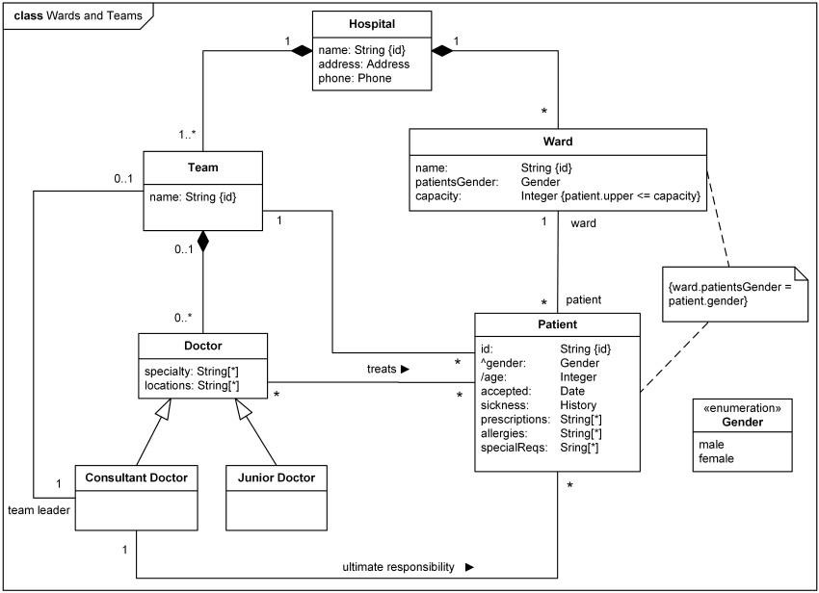

Class –Example-Hospital-Orgnization



##### Use Case Diagrams



Login

Password

Gmail

Doctor

Admin

* 1. **Module Hierarchy Diagram**

Feedback

Bill

Department

Nurse

Patient

Online Hospital Management System

* 1. **Component Diagram**



* 1. **Deployment Diagram**



* 1. **User Interface Design:**

###### Context level DFD:

Personal Details

OPD

0 Level

Online Hospital

Management

System

Bill Report

Bill Genrate Patient

Admin

Admin

Patient

* + 1. First Level DFD:

Persnal Detail of Patient Update

1.0

Admin

Patient Detail

Patient db

Update

Persnal Detail of Doctor

Admin

2.0

Doctor Details

Update

Doctor db

Patient details

3.0 Lab Report Generation

Update

Reports db

4.0 Bill Generation

Discharge

Doctor name & fees Patient Detail

##### ER Diagram

1

f

Doctor

Login

1

1

does

1

1

1

1

l

give

read

ogin

1

1

read

Feedback

1

1

1

1

r

manag

manag

1

1

ma

1

Admin

1

manage

Appointmen

Facility

ct Us

Conta

Registration

User

Us

About

##### State Diagram



* 1. **ActivityDiagram**

**Patient Doctor**



* 1. **Collaboration Diagram**

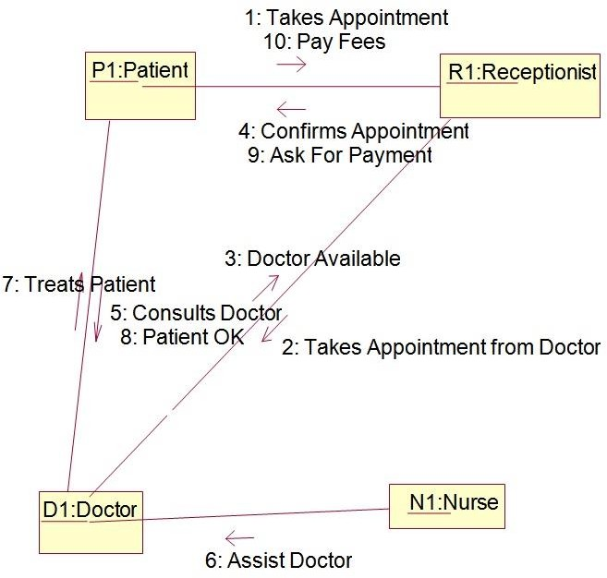

###### 12.Sequence Diagram

